**Outline:**

Introduction

**Character Creation**

**SPECIAL**

**Classes**

**Factions**

**Perks**

**Traits**

**Other**

**Game Mechanics**

**Combat**

**Dice**

**Turns**

**AP and Actions**

**Advantage and Disadvantage**

**Effective range**

**VATS**

**Cover**

**Exploration**

**Skills**

**Levelling Up and XP**

**Crafting**

Crafting recipes

Weapon modding

Pipe guns

Weapon and armour statuses

Misc.

**Radiation**

**Damage Types**

**Status Effects**

**Addiction**

**Karma**

Lore and Worldbuilding

**Maps**

**Main maps**

**Game map**

**Terrain map**

**POI map**

Local maps

Miami

Hollywood

Fort Lauderdale

WPB

Fort Myers

**Timeline**

**The story of Miami in Detail**

Appendixes

**Items**

**Weapons**

**Ballistic**

**Energy**

**Melee**

**Explosives**

**Ammunition**

**Apparel**

**Armour**

**Clothing**

**Power Armour**

**Aid**

**Mods**

**Junk**

Misc.

Faction Items

Locations

Characters

Wasteland Encounters

Mutation Table

Wild Wasteland

Character Sheets

# Introduction

Blah blah blah Blah blah blah Blah blah blah Blah blah blah Blah blah blah Blah blah blah Blah blah Blah blah blah Blah blah blah Blah blah blah Blah blah blah Blah blah blah Blah blah blah Blah blah

Blah blah blah Blah blah blah Blah blah blah Blah blah blah Blah blah blah Blah blah blah Blah blah

Blah blah blah Blah blah blah Blah blah blah Blah blah blah Blah blah blah Blah blah blah Blah blah

Blah blah blah Blah blah blah Blah blah blah Blah blah blah Blah blah blah Blah blah blah Blah blah

Blah blah blah Blah blah blah Blah blah blah Blah blah blah Blah blah blah Blah blah blah Blah blah

Blah blah blah Blah blah blah Blah blah blah Blah blah blah Blah blah blah Blah blah blah Blah blah

Blah blah blah Blah blah blah Blah blah blah Blah blah blah Blah blah blah Blah blah blah Blah blah

Blah blah blah Blah blah blah Blah blah blah Blah blah blah Blah blah blah Blah blah blah Blah blah

Blah blah blah Blah blah blah Blah blah blah Blah blah blah Blah blah blah Blah blah blah Blah blah

Blah blah blah Blah blah blah Blah blah blah Blah blah blah Blah blah blah Blah blah blah Blah blah

Blah blah blah Blah blah blah Blah blah blah Blah blah blah Blah blah blah Blah blah blah Blah blah

Blah blah blah Blah blah blah Blah blah blah Blah blah blah Blah blah blah Blah blah blah Blah blah

Blah blah blah Blah blah blah Blah blah blah Blah blah blah Blah blah blah Blah blah blah Blah blah

Blah blah blah Blah blah blah Blah blah blah Blah blah blah Blah blah blah Blah blah blah Blah blah

Blah blah blah Blah blah blah Blah blah blah Blah blah blah Blah blah blah Blah blah blah Blah blah

Blah blah blah Blah blah blah Blah blah blah Blah blah blah Blah blah blah Blah blah blah Blah blah

Table of Contents

Introduction 5

Character Creation 10

SPECIAL Score 11

Classes 13

Brigadier 14

Farmer 18

Fixer 22

Nomad 26

Scoundrel 30

Sniper 35

Soldier 39

Tech 43

Factions 48

Faction Descriptions 49

Brotherhood of Steel Remnants 49

Brotherhood of Gold 49

Brotherhood of Silver 49

Brotherhood of Copper 49

Brotherhood of Titanium 50

Brotherhood of Crystal 50

The Mutant Clan 50

Miami Institute Mutants 50

The Pillagers 51

The Brutists 51

The Bandits 51

The Nomads 51

The Miami Institute 51

The Gunners 52

Venetian Boys 52

Montana Cartel 52

Miami Militia 52

Conquistadors 52

Everglade Militia 53

West Palm Army 53

Fort Myers Militia 53

Vindi Clan 53

Vault-Tec 53

The Enclave 54

Perks 55

Strength 56

Perception 56

Endurance 57

Charisma 58

Intelligence 58

Agility 59

Luck 60

Traits 61

Non-Aligned Traits 61

Brotherhood Faction Traits 62

Raider Faction Traits 64

Mutant Faction Traits 65

Mercenary Faction Traits 66

Militia Faction Traits 67

Other Faction Traits 69

Other Character Creation Notes 70

Gear and Items 70

Alignment 70

Race 71

Skills 71

Initiative 71

Inventory 72

Health 72

Game Mechanics 73

Combat 74

Dice 74

Turns and Action Points 75

Actions 76

Advantage and Disadvantage 77

Effective Range 78

V.A.T.S. 79

Cover 79

Exploration 80

Skill Checks 80

Travel 81

Resting 81

Vehicles 82

Detailed Maps 82

Experience and Levelling Up 83

Radiation 84

Damage Types 85

Status Effects 86

Addiction 87

Karma System 88

Lore and Worldbuilding 89

Maps 90

Map of Miami and Surroundings in 2310 90

Terrain Map 91

POI Map 92

Local Maps 93

Downtown Miami (Placeholder) 93

Hollywood (Placeholder) 94

Fort Lauderdale (Placeholder) 94

West Palm Beach (Placeholder) 95

Fort Myers (Placeholder) 96

A Brief Timeline of Events 97

The Story of Fallout 99

Pre-War America 99

The Great War 101

The Story of the Miami Wasteland – In Further Detail 102

2310 105

Appendixes 106

Appendix A: Items 107

Weapons 107

Ballistic Weapons 107

Energy Weapons 119

Pipe Weapons 124

Melee Weapons 125

Explosives and Throwables 130

Ammunition 133

Ballistic Weapons 133

Energy Weapons 134

Apparel 135

Armour 135

Clothing 138

Power Armour 142

Aid 146

Alcohol 146

Chems 149

Drinks 152

Cooked Food 157

Raw Food 160

Mods 165

Ballistic Weapons 165

Energy Weapons 170

Pipe Guns 175

Armour and Clothing 180

Power Armour 185

Junk 191

Miscellaneous Items 192

Faction Items 193

Appendix B: Locations 194

Main POIs 194

Miami 194

Hollywood 194

Fort Lauderdale 194

West Palm Beach 194

Fort Myers 194

Appendix C: Characters 194

Appendix D: Character Sheets 194

Appendix E: Encounters 194

Table I: Mutation Table 194

Table II: Wild Wasteland Table 195

Table III: Loot Tables 195

# Character Creation

## SPECIAL Score

The SPECIAL score is the core of Fallout Miami’s character system. These traits are the base for which the rest of your skills are derived and are the blueprint for how you will build your character.

SPECIAL stands for:

S – Strength

* Raw physical strength. A high Strength is good for physical characters.

P – Perception

* The ability to see, hear, taste and notice unusual things. A high Perception is important for a sharpshooter.

E – Endurance

* Stamina and physical toughness. A character with a high Endurance will survive where others may not.

C – Charisma

* A combination of appearance and charm. A high Charisma is important for characters that want to influence people with words.

I – Intelligence

* Knowledge, wisdom and the ability to think quickly. A high Intelligence is important for any character.

A – Agility

* Coordination and the ability to move well. A high Agility is important for any active character.

L – Luck

* Fate. Destiny. An extremely high or low Luck will affect the character - somehow. Events and situations will be changed by how lucky (or unlucky) your character is.

Distributing you SPECIAL properly is key in creating a good character. The choice is up to you – do you keep some attributes high and some low? Or do you take a balanced approach. Both methods have advantages and consequences – the choice is yours. The next page will cover how SPECIAL attributes are derived.

SPECIAL attributes are graded on a scale from 1 to 10. There are two main methods to deriving your attributes, which will change depending on you or your group’s preferences. Both methods assume you are starting at level one.

##### Rolling Method

In the rolling method, you roll ten d8s and take the four lowest and three highest rolls from that set. You may then allocate each of those numbers to an attribute of your choice.

Example:

Lucy wants to make a character with high intelligence, luck, and charisma. She rolls her ten d8s, and gets the following results:

* 2, 3, 3, 4, 4, 5, 5, 7, 8, 8

Lucy then allocates the four lowest (2, 3, 3, 4) and three highest (7, 8, 8) scores to her character:

S: 2, P: 3, E: 4, C: 7, I: 8, A: 3, L: 8

##### Points Method

With the points method, you are given a set pool of 21 points to allocate as you wish. Additionally, ever SPECIAL attribute has a default of 1, so you’ll have 28 points of total SPECIAL score. The average total roll of four d8 die is 28, so you’re not technically losing out on points by using either method (although the rolling method can result in a lower total score with bad luck).

Example:

Nate wants to make a character with high luck, endurance, and perception. He allocates his points as follows:

S: 1, P: 6, E: 7, C: 2 , I: 2, A: 2, L: 8

As you might have notice, both methods are equally useful depending on your situation. If you want an unbalanced (min/maxed) character, the points method is better as it allows you to allocate unevenly as you please. It is also better if you have a very specific character build in mind.

The rolling method can be better if you are looking for a more balance build, and believe the odds are in your favour. Using this method can often be more fun, as it can lead to wackier, unpredictable results. At the end of the day, the allocation system you use won’t be so important in the long-term game. Coordinate with your group and GM to see what system suits your campaign best. And if your luck is terrible with the rolling method? Maybe your GM will be generous and let you reroll.

## Classes

The next step in character creation is to determine a “class”. Player class is crucial in Fallout Miami as it establishes your playstyle, as well as your future leveling opportunities. Your class also determines your starting gear, your skill proficiencies, and affects your perks.

Classes also have a unique impact on roleplaying: A character with the Fixerclass may talk in a more sophisticated and secretive form than a Farmer would. A character with the Soldierclass will certainly have more connections in the militaristic factions then someone with the Nomad class. Remember, for ideal role-playing, let the character’s mind be separate from your own, this means their knowledge and experience are their own, not shared with the player.

When creating a character, pick a class from the table below:

|  |  |  |
| --- | --- | --- |
| Class | Subclasses | Description |
| Brigadier | Breacher  Heavy | The brigadier is a heavy, tough, combat focused role. The brigadier is the centre of the party’s attacking force and shouldn’t be meddled with. |
| Farmer | Mass Production  Health Farmer  Ta No Kami | The farmer is a key role in supporting the party. An expert in producing food, and chems – also skilled in using equipment and tools to fight off foes. |
| Fixer | Kingpin  Contractor | Fixers get things done. A member of your party who can get you in contact with quest-givers, make deals, and talk their way out of a situation. |
| Nomad | Explorer  Cartographer  Wanderer | The nomad is a wanderer of the wastes and an expert of survival. Key for any group keen on exploration, self-sustenance, or travelling the wastes. |
| Scoundrel | Barman  Solo  Thief | The scoundrel is well-rounded and found in shady places. Able to talk their way out of any situation with their silver tongue, or shoot their way out if they have to. |
| Sniper | Ranger  Marksman  Strategist | The sniper provides long range support to the party with high-power long guns. Adaptable and detail oriented, an asset to any party facing heavy combat. |
| Soldier | Infantry  Power Armourer | The soldier is your first and last line of defence against the wastes. Tough, gritty, and an expert with a variety of weapons – a staple of any party. |
| Tech | Master Hacker  Mad Scientist  Crafter | The tech is an expert of all things related to gizmos or computers. Can build a new tool to get you through a situation, rig a trap, or hack a panel – whatever it takes to deal with the problem. |

Players should coordinate with their team to build a synergetic and effective party to travel the wastes. Think about what classes work well together, what roles are redundant, and what you’ll need for your campaign goals.

In the next pages, we’ll go into further detail of what each class does and how they progress.

### Brigadier

Levelling Table

|  |  |
| --- | --- |
| Level 1 | Weapon Proficiency, Starting Items |
| Level 2 | Subclass, Skill Proficiency |
| Level 3 | SPECIAL Level |
| Level 4 | *Melee Boost* |
| Level 5 | Weapon Proficiency |
| Level 6 | SPECIAL Level |
| Level 7 | Subclass Feature |
| Level 8 | *Psycho Killer* |
| Level 9 | SPECIAL Level |
| Level 10 | Weapon Proficiency |
| Level 11 | *Chem Man* |
| Level 12 | Subclass Feature |
| Level 13 | SPECIAL Level |
| Level 14 | Skill Proficiency |
| Level 15 | *Melee Boost* |
| Level 16 | Weapon Proficiency |
| Level 17 | SPECIAL Level |
| Level 18 | Subclass Feature |

**Weapon Proficiency**

At level 1, 5, 10, and 16, take proficiency in one of the following:

* Axes
* Swords
* Sledgehammers
* Blunt Weapons

**Starting Items**

In addition to standard items, Brigadiers receive:

* Sawed-Off Shotgun
* 12 Gauge Shells (12)
* Sledgehammer

**Subclass**

At 2nd Level, choose a subclass and reap its benefits. This cannot be changed.

**Breacher**

+2 to checks related to room entry.

**Heavy**

+10% to armour resistance.

**Skill Proficiency**

At levels 2 and 14, take proficiency in one of the following:

* Explosives
* Pacification
* Athletics

**SPECIAL Level**

At levels 3, 6, 9, 13, and 17, add one point to any of your SPECIAL scores, to a maximum of 10.

**Melee Boost**

At levels 4 and 15, you deal 30% more damage with melee weapons.

**Subclass Feature (Level 7)**

Based on which subclass you chose at level 2, pick your new ability from the following:

**Breacher**

For 10 seconds after entering a room, increase your damage resistance by 80%.

**Heavy**

Gain resistance to melee damage.

**Psycho Killer**

Killing people with a blunt melee weapon increases your Karma by 2 and decreases your sanity twice as fast.

**Chem Man**

Chems have doubled effects, but decrease your sanity one ever use.

**Subclass Feature (Level 12)**

Based on which subclass you chose at level 2, pick your new ability from the following:

**Breacher**

Sledgehammers can instantly break walls/doors. Sledgehammers also deal twice as much damage.

**Heavy**

The damage from every 2nd bullet is negated.

**Subclass Feature (Level 18)**

Based on which subclass you chose at level 2, pick your new ability from the following:

**Breacher**

Shotguns (excluding the sawed-off shotgun) have the ability to destroy doors. Shotgun shots can pierce through an enemy, hitting anything behind them.

**Heavy**

Movement speed penalties from armour and gear are negated. Enemy attacks cannot knock you back.

### Farmer

Levelling Table

|  |  |
| --- | --- |
| Level 1 | Weapon Proficiency, Starting Items |
| Level 2 | Subclass |
| Level 3 | Skill Proficiency |
| Level 4 | SPECIAL Level |
| Level 5 | *High Yields* |
| Level 6 | Subclass Feature |
| Level 7 | Weapon Proficiency |
| Level 8 | SPECIAL Level |
| Level 9 | *Crop Boost* |
| Level 10 | Skill Proficiency |
| Level 11 | Subclass Feature |
| Level 12 | *Health Boost* |
| Level 13 | SPECIAL Level |
| Level 14 | *Fertile Land* |
| Level 15 | Weapon Proficiency |
| Level 16 | Skill Proficiency |
| Level 17 | Subclass Feature |
| Level 18 | SPECIAL Level |

**Weapon Proficiency**

At level 1, 7, and 15, take proficiency in one of the following:

* Axes
* Spears
* Scythes
* Hunting Rifles
* Tools
* Unarmed Combat

**Starting Items**

In addition to the standard items, Farmers receive:

* Pitchfork
* Tato (5)
* Mutfruit (5)
* Hunting Rifle
* .308 Ammo (15)

**Subclass**

At 2nd level, choose a subclass and reap its benefits. This cannot be changed.

**Mass Production**

Produce twice as much produce when farming.

**Health Farmer**

Your grown produce provides twice as healing.

**Ta No Kami**

You can make melee weapons out of farming equipment. These all deal a d6 damage.

**Skill Proficiency**

At levels 3, 10, and 16, take proficiency in one of the following:

* Nature
* Animal Handling
* Barter
* Medicine
* Repair

**SPECIAL Level**

At levels 4, 8, 13, and 18, add one point to any of your SPECIAL scores, to a maximum of 10.

**High Yields**

You can use fertilizer to double produce yields.

**Subclass Feature (Level 6)**

Based on which subclass you chose at level 2, pick your new ability from the following:

**Mass Production**

Crops take up 50% less space and grow twice as fast when inside a room with a glass ceiling or walls.

**Health Farmer**

Your grown produce will remove 1 Rad when eaten.

**Ta No Kami**

While attacking on land owned by you or your faction, you deal 3 times more damage.

**Crop Boost**

At level 7, crops grow 50% faster and restore 50% more HP.

**Subclass Feature (Level 11)**

Based on which subclass you chose at level 2, pick your new ability from the following:

**Mass Production**

Your produce is worth 50% more CAPS when sold.

**Health Farmer**

You can use one chem on your produce when growing. The produce will then provide that bonus when consumed, however addiction is still possible.

**Ta No Kami**

You may remain in stealth while running/standing/making noise if you have a farm equipment weapon equipped.

**Health Boost**

Increase your HP by 2d10.

**Fertile Land**

At level 14, you are able to make any land fertile with your green thumb, and therefore can farm in any terrain.

**Subclass Feature (Level 17)**

Based on which subclass you chose at level 2, pick your new ability from the following:

**Mass Production**

Your farming skill allows you to instantly grow crops, even during the midst of battle (using 2 AP)

**Health Farmer**

Eating one of your produced foods will grant those effects to your entire party.

**Ta No Kami**

You can conceal any bladed weapon perfectly.

### Fixer

Levelling Table

|  |  |
| --- | --- |
| Level 1 | Weapon Proficiency, Starting Items |
| Level 2 | Subclass |
| Level 3 | SPECIAL Level |
| Level 4 | Skill Proficiency |
| Level 5 | Subclass Feature |
| Level 6 | *Smooth Talker* |
| Level 7 | SPECIAL Level |
| Level 8 | Subclass Feature |
| Level 9 | Weapon Proficiency |
| Level 10 | SPECIAL Level |
| Level 11 | Skill Proficiency |
| Level 12 | *Underground Connections* |
| Level 13 | SPECIAL Level |
| Level 14 | *Smooth Talker II* |
| Level 15 | Subclass Feature |
| Level 16 | SPECIAL Level |
| Level 17 | Skill Proficiency |
| Level 18 | *Secret Network* |

**Weapon Proficiency**

At levels 1 and 9, take proficiency in one of the following:

* Pistols
* Rifles
* Knives
* Pipe Weapons

**Starting Items**

In addition to the standard items, Fixers receive:

* 10mm Pistol
* 10mm Ammo (24)
* Switchblade
* Stimpak (2)
* Radaway (1)
* CAPS (75)

**Subclass**

At 2nd level, choose a subclass and reap its benefits. This cannot be changed.

**Kingpin**

You can now craft chems for 50% less resources. You now sell chems for 2x the price.

**Contractor**

Your underground connections allow you to smooth talk quest-givers into doubling their CAPS payout, with a persuasion check.

**SPECIAL Level**

At levels 3, 7, 10, 13, and 16, add one point to any of your SPECIAL scores, to a maximum of 10.

**Skill Proficiency**

At levels 4, 11, and 17, take proficiency in one of the following:

* Persuasion
* Intimidation
* Deception
* Investigation
* Trading
* Chemical Engineering

**Subclass Feature (Level 5)**

Based on which subclass you chose at level 2, pick your new ability from the following:

**Kingpin**

You can now craft chems and chem components on the go. Chem components sell for 2x the price.

**Contractor**

People fear your name. Gain advantage on all intimidation and persuasion checks.

**Smooth Talker**

Gain +1 charisma, and +2 to persuasion and deception.

**Subclass Feature (Level 8)**

Based on which subclass you chose at level 2, pick your new ability from the following:

**Kingpin**

Your chems are extremely pure and effective. Chem effects are doubled, and chem duration is increased by 50%.

**Contractor**

Your wrath is known to the wastes. Characters who make deals with you will very rarely ever break them.

**Underground Connections**

You are an expert at detecting illicit activity. +1 to perception, and +2 to investigation and looting.

**Smooth Talker II**

Gain +2 to persuasion and deception.

**Subclass Feature (Level 15)**

Based on which subclass you chose at level 2, pick your new ability from the following:

**Kingpin**

Your criminal enterprise is one of the greatest in the wasteland. You can recruit people with ease to sell your product via a charisma check with advantage. They provide you 100 CAPS each per week.

**Contractor**

You can publish bounties on anyone in the wasteland. The success chance formula is as follows:

Success Chance % = CAPS Spent / (Target Character Level + 2)

**Secret Network**

Your deep connection network allows you to strike favourable deals with ANY faction in the wastes, even remotely through courier delivery of contracts. You have double advantage on skill checks related to writing contracts or making deals.

### Nomad

Levelling Table

|  |  |
| --- | --- |
| Level 1 | Weapon Proficiency, Starting Items |
| Level 2 | Subclass |
| Level 3 | Skill Proficiency |
| Level 4 | SPECIAL Level |
| Level 5 | *Highwayman* |
| Level 6 | Weapon Proficiency |
| Level 7 | Skill Proficiency |
| Level 8 | Subclass Feature |
| Level 9 | *Camper* |
| Level 10 | Weapon Proficiency |
| Level 11 | Skill Proficiency |
| Level 12 | Subclass Feature |
| Level 13 | SPECIAL Level |
| Level 14 | Weapon Proficiency |
| Level 15 | Skill Proficiency |
| Level 16 | Subclass Feature |
| Level 17 | *Master of Evasion* |
| Level 18 | SPECIAL Level |

**Weapon Proficiency**

At levels 1, 6, 10, and 14, take proficiency in one of the following:

* Pipe Weapons
* Hunting Rifles
* Sniper Rifles
* Axes
* Knives
* Makeshift Weapons

**Starting Items**

In addition to the standard items, Nomads receive:

* Hunting Rifle
* Pipe Pistol (.308)
* .308 ammo (32)
* Survival Knife

**Subclass**

At 2nd level, choose a subclass and reap its benefits. This cannot be changed.

**Cartographer**

You are able to construct detailed maps of locations. Your investigation or perception while navigating locations is doubled.

**Explorer**

Your perception and endurance are increased by 1. +2 to Animal handling and Nature.

**Wanderer**

You work best alone. Upgrade 4 of your SPECIAL stats by 1 point when not in a party.

**Skill Proficiency**

At levels 3, 7, 11, and 15, take proficiency in one of the following:

* Animal Handling
* Nature
* Traps
* Radiation Resistance
* Survival
* Crafting

**SPECIAL Level**

At levels 4, 13, and 18, add one point to any of your SPECIAL scores, to a maximum of 10.

**Highwayman**

You now have access to a Chryslus Motors “Highwayman”, a four-seater sedan capable of traversing the wastes with ease. You can fuel it with microfusion cells.

**Subclass Feature (Level 8)**

Based on which subclass you chose at level 2, pick your new ability from the following:

**Cartographer**

Your expertise in navigation cut your party’s travel time in half.

**Explorer**

You’re an expert in exploring the wasteland. You can discover random POIs at twice your level.

**Wanderer**

You discover a Pip-Boy on your travels – in mint condition!

**Camper**

You have the ability to set up camps wherever you want without expending resources. These camps allow you to rest overnight and regenerate all stats.

**Subclass Feature (Level 12)**

Based on which subclass you chose at level 2, pick your new ability from the following:

**Cartographer**

Discovering new locations grants 5x more XP.

**Explorer**

Your wasteland experience has hardened you to radiation. Gain 50% less rads.

**Wanderer**

You’re time in the wastes has allowed you to craft makeshift chems. Using 10 junk, create a chem of your choice, but beware, it has a 50% chance to inflict poisoning.

**Subclass Feature (Level 16)**

Based on which subclass you chose at level 2, pick your new ability from the following:

**Cartographer**

You can now create a map once per day using 3 hours of effort. These maps can be sold at market for 1500 CAPS each.

**Explorer**

You and your party can now instantly travel between previously discovered locations.

**Wanderer**

When alone, you have advantage on all roles during combat.

**Master of Evasion**

Your wasteland skills make you undetectable while wandering the wasteland. You can evade any encounters with ease and can make shelters which can’t be discovered by creatures or enemies.

### Scoundrel

Levelling Table

|  |  |
| --- | --- |
| Level 1 | Weapon Proficiency, Starting Items |
| Level 2 | Subclass |
| Level 3 | Skill Proficiency |
| Level 4 | Weapon Proficiency |
| Level 5 | SPECIAL Level |
| Level 6 | Skill Proficiency |
| Level 7 | Subclass Feature |
| Level 8 | Weapon Proficiency |
| Level 9 | Skill Proficiency |
| Level 10 | *Lone Star* |
| Level 11 | Subclass Feature |
| Level 12 | Skill Proficiency |
| Level 13 | Weapon Proficiency |
| Level 14 | SPECIAL Level |
| Level 15 | Subclass Feature |
| Level 16 | *Assassin* |
| Level 17 | Weapon Proficiency |
| Level 18 | Subclass Feature |

**Weapon Proficiency**

At levels 1, 4, 8, 13, and 17, take proficiency in one of the following:

* Knives
* Suppressed weapons
* Throwing Knives
* Daggers
* Pistols (Only available after level 4)

**Starting Items**

In addition to the standard items, Scoundrels receive:

* Suppressor
* Deliverer Pistol
* .45 ammo (32)
* Lead pipe

**Subclass**

At 2nd level, choose a subclass and reap its benefits. This cannot be changed.

**Barman**

Gain advantage on strength checks when under the influence of alcohol. +2 to attacks and damage with improvised weapons when under the influence of alcohol.

**Solo**

Gain advantage on attacks with guns when the weapon is unseen or below a surface. Gain advantage on vehicle checks. Gain advantage when accompanied by a canine.

**Thief**

Gain proficiency in deception. You can pick locks and open safes as if they are one level lower. Novice locks and safes can be opened without a skill check.

**Skill Proficiency**

At levels 3, 6, 9, and 12, take proficiency in one of the following:

* Brawling
* Grappling
* Deception
* Persuasion
* Gambling

**SPECIAL Level**

At levels 5 and 14, add one point to any of your SPECIAL scores, to a maximum of 10.

**Subclass Feature (Level 7)**

Based on which subclass you chose at level 2, pick your new ability from the following:

**Barman**

Your alcohol induced rage gives you advantage on all ability checks not related to charisma, At the cost of a hangover after the next long rest, during which you will have disadvantage on Strength checks.

**Solo**

+1 to luck, and +2 to gambling.

**Thief**

+50% chance of success when pickpocketing or stealing.

**Lone Star**

Revolvers and pistols can be reloaded without using any time or AP. Revolvers and pistols only consume ammo every other shot.

**Subclass Feature (Level 11)**

Based on which subclass you chose at level 2, pick your new ability from the following:

**Barman**

Gain advantage on Charisma checks when in a building that sells alcohol.

**Solo**

Double damage with handguns.

**Thief**

Advantage on attacks with daggers and knives.

**Subclass Feature (Level 15)**

Based on which subclass you chose at level 2, pick your new ability from the following:

**Barman**

When under the influence of alcohol, on the first turn of combat you can knock an enemy unconscious, instantly.

**Solo**

When you attack an enemy before they attack you, you are guaranteed to score a critical hit, you shot first.

**Thief**

When in a shadow, you are undetectable.

**Assassin**

You can move to any shadowed area on the map, even if it is farther than your movement allows. This uses all of your movement for that turn. This does not provoke opportunity attacks, and you will not be seen or detected during this movement.

**Subclass Feature (Level 18)**

Based on which subclass you chose at level 2, pick your new ability from the following:

**Barman**

You channel your alcohol induced mindset into your soul. You can now trigger all previous barman effects for an entire combat stage, at the cost of 5 AP.

**Solo**

Your critical hit chance is doubled. +2 to luck and charisma.

**Thief**

You can instantly kill any target from the shadows, while outside of combat.

### Sniper

Levelling Table

|  |  |
| --- | --- |
| Level 1 | Weapon Proficiency, Starting Items |
| Level 2 | Subclass |
| Level 3 | *Sharpshooter* |
| Level 4 | Skill Proficiency |
| Level 5 | SPECIAL Level |
| Level 6 | *Deadeye* |
| Level 7 | Skill Proficiency |
| Level 8 | Subclass Feature |
| Level 9 | Weapon Proficiency |
| Level 10 | SPECIAL Level |
| Level 11 | Skill Proficiency |
| Level 12 | Subclass Feature |
| Level 13 | *Extreme Range* |
| Level 14 | SPECIAL Level |
| Level 15 | Skill Proficiency |
| Level 16 | *Ghillie* |
| Level 17 | Weapon Proficiency |
| Level 18 | SPECIAL Level |

**Weapon Proficiency**

At levels 1, 4, 8, 13, and 17, take proficiency in one of the following:

* Rifles
* Sniper Rifles
* Concealable Weapons
* Batons
* Knives
* Throwables

**Starting Items**

In addition to the standard items, Snipers receive:

* Advanced Hunting Rifle
* .308 ammo (24)
* Suppressor
* 4x Scope
* Extendable Baton

**Subclass**

At 2nd level, choose a subclass and reap its benefits. This cannot be changed.

**Ranger**

You specialize in long range battlefield support. Disadvantage on long range shots is removed, and your critical chance for long range shots is increased by 10%.

**Marksman**

Close range combat support is your middle name. Your critical chance with semi-automatic rifles is increased by 30% when within 200m.

**Strategist**

You are great at planning combat on the fly. +2 initiative, and +3 AP.

**Sharpshooter**

You can now craft scope and bipod attachments for 3 pieces of assorted junk, per level of item. (level 1: 3 pieces, level 2: 6 pieces, etc.)

**Skill Proficiency**

At levels 4, 7, 11, and 15, take proficiency in one of the following:

* Critical Chance
* Crafting
* Nature
* Pacification
* Stealth
* V.A.T.S.

**SPECIAL Level**

At levels 5, 10, 14, and 18, add one point to any of your SPECIAL scores, to a maximum of 10.

**Deadeye**

+30% critical chance on attacks with semi-automatic or non-automatic rifles.

**Subclass Feature (Level 8)**

Based on which subclass you chose at level 2, pick your new ability from the following:

**Ranger**

You now have advantage on long range shots with scoped rifles. Critical chance on long range shots is increased by a further 10%.

**Marksman**

You can now craft jumping landmines to defend your sniping position. These jumping mines have an 8m kill radius, and bounce before going off – meaning you will be unscathed if laying prone.

**Strategist**

Your subclass features from level 2 now affect all party members within 5m. +2 levels to lucky miss and +1 level to V.A.T.S.

**Subclass Feature (Level 12)**

Based on which subclass you chose at level 2, pick your new ability from the following:

**Ranger**

As a master of sniping, you now make guaranteed critical hits on all long-range shots, with any type of weapon. Gain proficiency with V.A.T.S.

**Marksman**

Attacks with scoped weapons all only require 1AP. V.A.T.S now uses no AP when at a range of greater than 50m.

**Strategist**

All of your previous subclass features now apply to your entire party during combat. You now have advantage on initiative rolls.

**Extreme Range**

Gain an extra advantage roll for every 300m you are away from the target.

**Ghillie**

You are a master of sniper disguise and can create ghillie armour mods using 3 junk each. When equipped on all pieces of armour, you are undetectable while not moving.

### Soldier

Levelling Table

|  |  |
| --- | --- |
| Level 1 | Weapon Proficiency, Starting Items |
| Level 2 | Subclass |
| Level 3 | Skill Proficiency |
| Level 4 | Weapon Proficiency |
| Level 5 | Subclass Feature |
| Level 6 | Weapon Proficiency |
| Level 7 | SPECIAL Level |
| Level 8 | Weapon Proficiency |
| Level 9 | Subclass Feature |
| Level 10 | Skill Proficiency |
| Level 11 | *Full Metal Jacket* |
| Level 12 | SPECIAL Level |
| Level 13 | Weapon Proficiency |
| Level 14 | Skill Proficiency |
| Level 15 | Weapon Proficiency |
| Level 16 | Subclass Feature |
| Level 17 | SPECIAL Level |
| Level 18 | Weapon Proficiency |

**Weapon Proficiency**

At levels 1, 4, 6, 8, 13, 15, and 18, take proficiency in one of the following:

* Rifles
* Shotguns
* Pistols
* Heavy Weapons
* Combat Weapons
* Knives
* Batons
* Throwables

**Starting Items**

In addition to the standard items, Soldiers receive:

* Combat Rifle
* 5.56 ammo (32)
* Combat Knife

**Subclass**

At 2nd level, choose a subclass and reap its benefits. This cannot be changed.

**Infantry**

+10% crit chance for automatic rifle attacks. Your automatic rifles take half as much wear and tear due to your familiarity with the weapon. Melee attacks with automatic rifles do not require a check.

**Power Armourer**

You are trained in the use of power armour. Automatically gain the “Power Armour Training” perk. Power armour drains fusion cores 50% slower.

**Skill Proficiency**

At levels 3, 10, and 14, take proficiency in one of the following:

* Athletics
* Brawling
* Explosives
* First Aid
* Grappling
* Pacification
* V.A.T.S.

**Subclass Feature (Level 5)**

Based on which subclass you chose at level 2, pick your new ability from the following:

**Infantry**

Your training and expertise with automatic rifles allow you to attack using them without a check.

**Power Armourer**

After reading many manuals, you’ve become familiar with power armour repair. You can now use junk to repair your power armour. 1 junk = 5% repair.

**SPECIAL Level**

At levels 7, 12, and 17, add one point to any of your SPECIAL scores, to a maximum of 10.

**Subclass Feature (Level 9)**

Based on which subclass you chose at level 2, pick your new ability from the following:

**Infantry**

Combat in the wasteland has toughened you up. +50HP, +1 endurance, and +1 to radiation resistance, survival, medicine, and traps.

**Power Armourer**

You and your power armour are now like one. You can upgrade power armour levels using 10 junk per level.

**Full Metal Jacket**

Your ammo is upgraded to full metal jacket, allowing all of your shots to pierce basic cover, and up to 3 normal sized bodies. The effects of this stack with other ammo types (AP, hollow point, etc.).

**Subclass Feature (Level 16)**

Based on which subclass you chose at level 2, pick your new ability from the following:

**Infantry**

All combat weapons now use half as much ammo when firing. Your critical hit chance with combat weapons increases by 25%. You can modify combat weapons at a workbench to use any kind of ammo, without changing the damage or range of the weapon.

**Power Armourer**

You can now construct a full suit of t-60 power armour using the following: 40 Aluminium, 30 Adhesive, 30 Circuitry, 10 Copper, 5 Fiber Optics, 5 Glass, 30 Gears, 20 Lead, 10 Nuclear Material, 3 Oil, and 10 Steel.

### Tech

Levelling Table

|  |  |
| --- | --- |
| Level 1 | Weapon Proficiency, Starting Items |
| Level 2 | Subclass |
| Level 3 | Skill Proficiency |
| Level 4 | SPECIAL Level |
| Level 5 | *Intellectual* |
| Level 6 | Skill Proficiency |
| Level 7 | Subclass Feature |
| Level 8 | SPECIAL Level |
| Level 9 | Weapon Proficiency |
| Level 10 | Skill Proficiency |
| Level 11 | Subclass Feature |
| Level 12 | SPECIAL Level |
| Level 13 | Skill Proficiency |
| Level 14 | Subclass Feature |
| Level 15 | SPECIAL Level |
| Level 16 | *Atomic Wizard* |
| Level 17 | Skill Proficiency |
| Level 18 | Subclass Feature |

**Weapon Proficiency**

At levels 1 and 9, take proficiency in one of the following:

* Pistols
* Laser Weapons
* Plasma Weapons
* Syringers

**Starting Items**

In addition to the standard items, Snipers receive:

* Laser Pistol
* Microfusion Cell (12)
* Stun Baton
* Damaged Pip-Boy

**Subclass**

At 2nd level, choose a subclass and reap its benefits. This cannot be changed.

**Master Hacker**

You instantly gain all levels of the Hacker Perk.

**Mad Scientist**

The power of science flows through your veins! You have advantage on any technology or science related checks.

**Crafter**

Your technical skills are enough that workbenches are mostly irrelevant. You can craft tech and chemical compounds on the go.

**Skill Proficiency**

At levels 3, 6, 10, 13, and 17, take proficiency in one of the following:

* Chemical Engineering
* Crafting
* Medicine
* Repair
* Explosives
* Traps
* Radiation Resistance

**SPECIAL Level**

At levels 4, 8, 12, and 15, add one point to any of your SPECIAL scores, to a maximum of 10.

**Intellectual**

Increase your intelligence by 1. You have advantage on all intelligence related checks.

**Subclass Feature (Level 7)**

Based on which subclass you chose at level 2, pick your new ability from the following:

**Master Hacker**

You can now reset terminal passwords, blocking anyone from using it unless you tell them the code.

**Mad Scientist**

You have reached a state of attument with science! Reading scientific literature during combat gives you 2 turns of advantage on rolls and +2AP.

**Crafter**

You can now craft any clothing or armour using 10 pieces of wasteland junk. You can craft ammo easily (even on the go) using 1 lead and 1 gunpowder to make 5 ammo.

**Subclass Feature (Level 11)**

Based on which subclass you chose at level 2, pick your new ability from the following:

**Master Hacker**

You can now use a pip-boy or digital interface to hack any electronic object, including but not limited to: explosives, generators, power armour, etc.

**Mad Scientist**

Alchemy allows you to create junk out of materials found in the wasteland. Once per day, using 2 hours, you can create 15 pieces of wasteland junk of your choice (they don’t all have to be the same).

**Crafter**

You can now create any armour or weapon mods using 5 aluminium, 5 circuitry, and 2 plastic.

**Subclass Feature (Level 14)**

Based on which subclass you chose at level 2, pick your new ability from the following:

**Master Hacker**

Your hacking ability allows you to take control of synths or power armour, remotely manipulating their movements using your Pip-Boy. You can only control one entity at a time.

**Mad Scientist**

Radiation is futile. Your scientific aura repels all radiation from your body. You now gain 0 Rads from the environment (Rad inducing attacks still affect you).

**Crafter**

You can create general mods for apparel and weapons that double their effects when equipped.

**Atomic Wizard**

You can now craft fusion cells, microfusion cells, plasma cells, and 2mm EC ammo using just 1 aluminium each.

**Subclass Feature (Level 18)**

Based on which subclass you chose at level 2, pick your new ability from the following:

**Master Hacker**

You can remotely hack from 30m away using a Pip-Boy or power armour.

**Mad Scientist**

Your radioactive aura recharges fusion cores in your inventory while you move.

**Crafter**

You can instantly upgrade weapons and armour to their highest level.

## Factions

Your choice of faction is a crucial part of roleplay and character design. Factions influence your traits, starting connections, starting location, quest opportunities, and in some cases access to gear. A common option is also starting as non-aligned (no faction), which has its own benefits.

Notably, certain factions will have karma requirements. Karma will be explained in further detail later, but for now, know that your faction will affect your starting karma, and falling outside of the karma requirement for the faction may result in being removed.

Some factions may also require you to be a certain race to join, notably the super mutants who stick to their own, and most Brotherhood factions who are averse to ghouls and mutants.

Leaving or being removed from a faction removes your faction trait and comes with roleplaying implications as well.

Below see a quick overview of the factions present in Miami:

|  |  |  |  |
| --- | --- | --- | --- |
| Faction | Group | Karma Requirement | Location |
| Non-Aligned | N/A | N/A | Anywhere |
| Brotherhood Of Steel Remnants | Brotherhood | Greater than 0 | North Bay Village |
| Brotherhood of Gold | Brotherhood | Less than 10, greater than -30 | Key Biscayne |
| Brotherhood of Silver | Brotherhood | Greater than 30 | Rising Tides Waterpark |
| Brotherhood of Copper | Brotherhood | Greater than 25 | Barnes Sound Supermine |
| Brotherhood of Titanium | Brotherhood | Greater than 10 | Vault 216 |
| Brotherhood of Crystal | Brotherhood | Less than 10, greater than -30 | Hollywood Sewers |
| The Mutant Clan | Super Mutants | Greater than -10 | Mutant Mound |
| Miami Institute Mutants | Super Mutants | Greater than 10 | Everglades |
| The Pillagers | Raiders | Less than -25 | Pillager Camp |
| The Brutists | Raiders | Less than -50 | Brutist Camp |
| The Bandits | Raiders | Less than -10 | Castille Bandito |
| The Nomads | Raiders | Less than 0 | Nomad Camp |
| Miami Institute Surface Force | Miami Institute | Greater than -10 | Any Institute Territory |
| Miami Institute HQ | Miami Institute | Greater than 10 | Institute Airship |
| Gunners | Mercenaries | Less than 90 | Chryslus Stadium |
| Venetian Boys | Mercenaries | Less than 60 | Belle Isle |
| Montana Cartel | Mercenaries | Less than 25 | Montana Mansion |
| Miami Militia | Militia | Greater than 20 | Miami City Hall |
| Conquistadors | Militia | Greater than -10 | Forward Operating Camp |
| Everglade Militia | Militia | Greater than 10 | Flamingo |
| West Palm Army | Militia | Greater than 0 | Palm Beach Airbase |
| Fort Myers Militia | Militia | Greater than 5 | Fort Myers City Hall |
| Vindi Clan | N/A | Greater than 30 | Alligator Alley Truckstop |
| Vault-Tec | N/A | Greater than 40 | Any VT inhabited vault |
| The Enclave | N/A | Less than -40 | [REDACTED] |

### Faction Descriptions

#### Brotherhood of Steel Remnants

The Brotherhood of Steel (abbreviated BoS) is a paramilitary order of soldiers formed shortly after the Great War, focused on obtaining and hoarding technology. The BoS is generally highly honourable, and strictly follows a guiding document called the codex.

The Brotherhood of Steel arrived in Miami in 2256. A group of the East coast BoS proceeded to Miami after hearing rumors about vast military technology supplies in the area and detecting huge electric activity. By 2270, the BoS began to collapse into a number of splinter faction, and just a few remaining squads and elders remained truly loyal to the entire codex. They are based out of an area of Miami called the North Bay Village, an island in the Miami lagoon.

#### Brotherhood of Gold

The Brotherhood of Gold (abbreviated BoG) is a splinter faction of the BoS, one of the first to break off of the main faction. A few paladins and elders of the BoS realized around 2271 that they quite enjoyed inflicting terror on members of the wastes and found that they could make huge amounts of money with their power. The became BoG what is essentially a band of raiders with style, using high energy weapons and power armour to drain as much wealth as they can from the wasteland into the coffers of their elders. The BoG is notoriously known for their gold plated “T-60g” power armour, which their paladins and elders always wear. They are based out of Key Biscayne, and island just south of central Miami.

#### Brotherhood of Silver

The Brotherhood of Silver (abbreviated BoSi) is a splinter faction of the Brotherhood of Steel, the first to leave the order. By the time of 2270, a number of proctors, elders, scribes, and knights believed that the BoS was straying too far from the codex and had disagreements with certain parts of the codex. Knight Krell led an exodus of 27 squads of the BoS and set up a new camp in the Rising Tides Waterpark. They became known as good samaritans of the wasteland, helping all those in need, with progressive approaches to their relations with ghouls and super mutants, even welcoming some into their ranks.

#### Brotherhood of Copper

Shortly prior to the Great War, a massive copper “supermine” was built in the Barnes Sound, a feat of engineering, draining over a square kilometer of water to mine a one-of-a-kind copper deposit. In 2269, a BoS detachment was sent to claim the mine, but realized it would make more sense to keep it for themselves. They reactivated the vast defence systems of the structure and declared themselves the Brotherhood of Copper (BoC). They keep mostly to themselves, selling output from the mine to other factions of the wasteland. While not totally abstinent from outsiders, they are more fearful than most factions about allowing other wastelanders into their ranks.

#### Brotherhood of Titanium

With the arrival of excess BoS forces from outside Miami, tensions only grew as infighting between the groups spiraled out of control. Inhabitants of the BoS controlled Vault 216 took this opportunity to override BoS command and seal the doors of the vault and declare their independence as the “Brotherhood of Titanium”.

Together, the original Vault 216 Vault Dwellers, BoS members who had been posted there, and BoS members who had been sent from out west and defected, joined together and prospered. Through ruthless experiments, they made their income by selling data to organizations like the Miami Institute or the BoS.

#### Brotherhood of Crystal

An internal dispute in the Brotherhood of Gold in 2273 about the validity of chem trading led to Elder Turbish and men loyal to him leaving the group and fleeing into the city’s depths. It was there that they met Big Malone of the Miami Triggermen, uncle to the notorious Skinny Malone in the Boston Commonwealth. Together, they formed the Brotherhood of Crystal (BoCr) and fled into the Miami subway system. Then with some help from connections in the BoT, they were able to set up many chem labs across the city. With the strength and resources of the Brotherhood, and the knowledge and reputation of the Triggermen, they became notorious criminals.

This would be the last of the Brotherhood factions to be formed.

#### The Mutant Clan

During the Great War of 2077, an experimental bomb was dropped near Fort Lauderdale, dispersing intense radiation into the environment which instantly mutated life forms in the area, turning the humans into super mutants – similar to ones created using FEV, with a few notable differences: blue skin, loss of all hair, and no change to their height. This created much smaller but equally powerful mutants who eventually organized under a king. The group has sustained this monarchy ever since, running their operations out of a hive called Mutant Mount, west of Fort Lauderdale. Highly dangerous and only friendly to other mutants and ghouls, the Mutant Clan is not to be trifled with unless you are sufficiently prepared.

#### Miami Institute Mutants

In 2198, the Miami Institute began pumping experimental FEV samples into the water and food supplies around the Naples area. Quite quickly, this resulted in heavy mutation similar to mutants on the west coast of the United States. These super mutants have no structure or hierarchy, and generally travel in packs of ~20, hunting wastelanders for sport. As of 2310, the Miami Institute has been replacing mutants with synths, using them as proxies to influence attacks on wasteland militia locations without taking direct blame.

These mutants are highly dangerous and should probably be avoided at all costs.

#### The Pillagers

The Pillagers are a general term for a subset of raiders known for their tribal and shamanist culture, revolving around human sacrifice to please their gods. Pillager tribes are quite unorganized and generally operate independently. Even though they are small, Pillager tribes should be avoided as they can be very deadly, even if not encountered often. Beliefs and practices may differ from tribe to tribe, and tribes can range in size from a few dozen to a few hundred members.

#### The Brutists

Out of the four main raider clans, these are likely the worst to encounter. These raiders seek pleasure in brutally murdering and torturing innocent wastelanders – often making it their only goal. Extremely unorganized, the Brutists operate in small, isolated cells of 20-30 members, scattered across all of the Florida wasteland. They often conflict with other raider clans and are usually hunted down and destroyed as soon as their camps are discovered.

#### The Bandits

The Bandits are the most organized clan of raiders, following a hierarchical and rigid structure where small cells operate across the wasteland, bringing in CAPS and resources which are sent up the chain to the clan leaders, with intermediary bosses taking their cut. Based out of Castille Bandito, a fortress in Belle Glade, the bandits run a huge criminal enterprise, often collaborating with other factions to bring in huge scores. Don’t let their ponchos, cowboy hats, six shooters, and overall poor imitation of old west bandits fool you – the Bandits are just as deadly and dangerous as any other raider clan (although definitely more focused on CAPS instead of just terror).

#### The Nomads

Known well across Miami for various atrocities, the Nomads are a newer raider clan who travel in camps of hundreds of members, looking for food, water, and shelter. When a Nomad camp is set up, they exterminate all life in the area to protect what they see as theirs, and when the resources are exhausted, repeat the same process elsewhere. The nomad camps follow a loose hierarchy and still report to a central Nomad council, based somewhere around the area of Hollywood. Generally, the least dangerous of the four clans, but if approached, become the absolute worst to deal with.

#### The Miami Institute

In 2156, scouts from the Commonwealth Institute were sent to investigate the vast weapons and tech caches in the Miami area. After setting up a large base of operations similar to the one found in the Commonwealth, the Miami Institute began mass weapons research, contributing greatly to the Commonwealth Institute’s military development. By 2190, the Miami Institute became emboldened enough to cut off all contact with the Commonwealth, and began to develop synth technology on their own. After being chased out of their original base of operations upon the arrival of the Brotherhood of Steel, the Miami Institute set up a mobile base aboard a massive nuclear powered cargo jet, where they circle Florida constantly – using the teleportation relay to refuel the jet.

#### The Gunners

A mercenary faction spanning the entire East Coast, the Gunners are a highly organized band of mercenaries taking inspiration from the structure of the pre-war military. The Gunners are known for taking any job, no matter how bad, for the right price – leaving them complicit in numerous massacres across the wasteland. After integrating a number of other mercenary groups around 2300 – notably Talon Company – the Gunners spread to the Miami area, taking on jobs with ruthless efficiency where they could and building up a nasty rap sheet. Based out of Chryslus Stadium the Gunners are best avoided, unless you’re looking for some low-karma CAPS or a bullet to the brain.

#### Venetian Boys

The Venetian Boys are a gang of crooks who run illicit gambling and chem operations throughout the Miami core. Headquartered on Belle Isle, a chain of islands in the lagoon, they generally keep to themselves and wont mess with you unless you owe some CAPS. Respected among wastelanders for their strict code of honour and loyalty in business, they are also feared for their harsh retaliation when crossed.

#### Montana Cartel

Known for dealing in highly addictive and hard chems, the Montana Cartel is a violent network of extremely dangerous chem dealers, who design, produce, and distribute the most dangerous chems around. They have also succeeded in cornering the Addictol market, in an attempt to prevent their customers from getting away from their product. Not much is known about them, as their leadership stays quite secretive, hunkered down in their highly defended safehouse in Miami Beach.

#### Miami Militia

The last remnants of the original post-war Miami government, the Miami Militia is still to this day attempting to bring order and safety to the wasteland. Made up of decently equipped volunteer fighters, they maintain order in small pockets of the Miami core, notably in and around the old city hall. Welcoming to most outsiders, they are always ready to give a helping hand, a place to stay, or a well-paying job.

#### Conquistadors

Dawned in historical clothing, the Conquistadors are the primary line of defence in Charlotte Harbour against the scourge of the wasteland. They have maintained relative order in the area, keeping most raiders and mutants outside of the town walls. Their main base of operations is in the Ponce de Leon museum (where they found their famous uniforms), however they can be found throughout the area south of Charlotte Harbour, patrolling and dealing with trouble. They are usually a well-run and honourable force, but due to their size, often have corrupt officials taking bribes or extorting locals.

#### Everglade Militia

Founded in 2272 with the express intention of clearing out mutations caused by the Institute and the Vindi Clan, the Everglade Militia is a band of tough explorers who are experts in hunting mutant beasts but are happy to keep the peace in the Everglades as well. Based out of a small pre-war settlement named Flamingo, they are an upstanding and respected group in Miami, facing occasional conflict only with the Institute, Vindi Clan, and both super mutant groups.

#### West Palm Army

The largest and most organized of the militias, the West Palm Army tries to keep the peace in the West Palm Beach area but often finds themselves in intense conflict with many other factions. Well-armed with real combat gear and armour, they can be found at the Palm Beach Airbase, a prewar airport which converted to an airbase in 2076 and stocked with fresh weapons, just before the bombs fell. Generally less welcoming to outsiders than other militias due to fears of infiltration but can be befriended quickly if loyalty is proven.

#### Fort Myers Militia

A branch of the Miami militia who now operates mostly autonomously due to lack of resources and distance between the two cities. In near constant conflict with the Miami institute mutants.

#### Vindi Clan

In the summer of 2258, a detachment of BoS soldiers became stranded deep in the everglades taking shelter at an abandoned truckstop off Alligator Alley. Driven mad by the toxic environment, they began their research on the local flora and fauna and created a new, highly potent FEV. Among their various experiments, some had been released into the wild, spread across the wasteland. Many of the local creatures were affected, resulting in FEV mutated versions of the already radiation inflicted American Alligator and American Crocodile, as well as countless other wetland species – turned into mutated beasts. The Vindi clan has now mostly dispersed, living with the wildlife in pockets of the swamps, with their creations terrorizing the Miami area and making the everglades very dangerous.

#### Vault-Tec

A pre-war corporation responsible for the construction of all of the vaults – nuclear shelters – across the United States. In the context of picking a faction, being a part of Vault-Tec means being a vault dweller, a resident of one of the vaults found across the wasteland. Vault dwellers have a unique way of looking at the wasteland, as most have very little or zero exposure to the outside world, depending on the vault they come from.

#### The Enclave

A highly clandestine organization from before the bombs fell, they pull the strings across the wasteland. After suffering massive losses in California and the Capital Wastes, the Miami sect of the Enclave is one of the last remaining pockets of pre-war power in America. With highly advanced and secretive technology, they hope to someday exterminate and repopulate the wasteland with their own members who they see as “pure”. They operate out of an offshore oil rig, the exact location of which is unknown and kept top-secret.

## Perks

Perks are a critical part in defining your character’s abilities and team synergy. It will be important when picking perks to consider what your team is picking, as well as what your own class and subclass do to your character design.

When creating a character, you may choose three perks from the following section to start with.

* After character creation, upon each level up you may select an additional perk or increase the level of one you already have.
* Perks are divided based on their corresponding SPECIAL attribute but generally don’t have a SPECIAL level requirement for use.
* Some perks have only one level and are highlighted with the perk named underlined.

#### Strength

* Armourer – You can now apply armor mods without a workstation.
* Basher – Gun melee attacks do 20% more damage, per perk level.
* Big Leagues – Melee weapon attacks do 10% more damage, per perk level.
* Blacksmith – You can now apply melee weapon mods without a workstation.
* Heave, Ho! – Thrown weapons do 20% more damage, per perk level.
* Heavy Gunner – Heavy weapon attacks do 10% more damage, per perk level.
* Iron Fist – Punching attacks do 20% more damage, per perk level.
* Pain Train – Attacks while in power armor do 10% more damage, per perk level.
* Rooted – While standing still gain 5% damage resistance, per perk level. Melee attacks do 5 more damage.
* Steady Aim – Gain the ability to fire a holstered weapon.
* Stonewall – Increase you’re BC against melee attacks by 1, per perk level.
* Super Slam! – You have a 15% chance, per level, to knock an enemy prone with a melee attack.
* Unstoppable Force – Decrease an enemy’s BC (block chance) by 1, per perk level.

#### Perception

* Awareness – When V.A.T.S. is activated, the GM must tell you the targeted enemy’s weaknesses. Increase V.A.T.S. hit chance by 5%.
* Concentrated Fire – Every V.A.T.S. attack on the same body part gains a 5% hit chance, per perk level.
* Demolition Expert – Double explosive damage, for every level of this perk
* Friend of the Night – At night (20:00-6:00), gain one dice of advantage (per level) on Stealth and Strength checks.
* Infiltrator – Gain one retry, per perk level, on a failed lockpicking check.
* Light Step – Gain one dice of advantage per perk level on saving throws for traps.
* Locksmith – You can now pick locks and safes equal to your perk level, Novice - 1, Advanced 2, Expert - 3, Master - 4.
* Pickpocket – You gain a 10% pickpocket chance per perk level.
* Refractor – You gain 10% energy resistance per perk level.
* Rifleman – Non-automatic rifles do 20% more damage, per perk level
* Sniper – Attacks with bolt action or scoped rifles do 10% more damage, per perk level.

#### Endurance

* Adamantium Skeleton – Limbs take 20% less damage, per perk level.
* Aquaboy/Aquagirl – You no longer take Rads while in water and are undetectable in the water. You can breathe in water.
* Cannibal – You can eat bodies to regain HP.
* Chem resistant – You cannot become addicted to chems.
* Ghoul-Ish – You gain 1 HP for every Rad you take, per perk level.
* Lead Belly – You don’t take Rads from eating or drinking.
* Life giver – You gain 5 HP every level, per perk level.
* Night Person – The dark slowly depletes your Rads. You take 10% less damage in the nighttime (20:00-6:00).
* Purifier – You do 20% extra damage, per perk level, with melee and Unarmed weapons against centaurs, night stalkers, spore plants, spore carriers, deathclaws and super mutants.
* Rad Resistance – You gain 10% radiation resistance per perk level.
* Rad Absorber – Lose 25% of your Rads, per perk level, at a short rest.
* Size Matters – Attacks with a Fat Man or Flamer do 10% more damage, per perk level.
* Solar Powered – Sunlight slowly depletes your Rads. You take 10% less damage in the daytime (7:00-19:00).
* Toughness – You gain 10% damage resistance per perk level. This only applies to damage with an unspecified type.

#### Charisma

* Animal Friend – You can now recruit an animal to be your companion for the battle.
* Attack Dog – Your animal companion gains 10% damage, per perk level.
* Black Widow – You do 10% more damage to females, per perk level
* Cap Collector – Advantage on persuasion rolls related to haggling.
* Child At Heart – You do 10% more damage to kids, per perk level.
* Ferocious Loyalty – Party members gain 10% HP, per perk level, when your HP is below 20%.
* Impartial Meditation – You gain one dice of advantage on all speech related rolls, per perk level, when you have neutral karma.
* Inspirational – Your companion takes 10% less damage, per perk level.
* Institute Boy/Girl – +2 INT and +2 PER, per perk level.
* Intimidation – You gain one dice of advantage on Intimidation rolls, per perk level.
* Lady Killer – You do 10% more damage to males, per perk level.
* Master Trader – Items cost 10% less CAPS, per perk level.
* Party Girl! – You are immune to alcohol addiction, and the effects of alcohol are doubled.
* Wasteland Whisperer – You can pacify and command a wasteland creature for the duration of the combat.

#### Intelligence

* Chemist – The effects of chems are increased by 50% per perk level.
* Entomologist – 10% more damage to insects, per perk level.
* Gun Nut – You can now craft and apply weapon mods without a workstation.
* Hacker – Gain the ability to hack terminals, with one dice of advantage per perk level.
* Medic – Stimpaks restore 20% more HP per perk level.
* Nerd Rage! – <Prerequisite - INT 10> When HP is below 25%, you do 15% more damage and 15% damage resistance per perk level.
* Nuclear Physicist – Energy weapons do 10% more damage per perk level, and fusion cores last twice as long – You have disadvantage on Strength checks.
* Robotics Expert – 10% more damage to robots, per perk level.
* Scrapper – One advantage dice per perk level, on luck checks and checking containers.
* Swift Learner – One dice of advantage, per perk level, when rolling for a perk level, only AFTER character creation.
* V.A.N.S. – One advantage dice per perk level, on investigation checks. +2 Perception at perk level 2.

#### Agility

* Action Boy – One extra AP per perk level.
* Blitz – Increase V.A.T.S. melee range by 10 feet per perk level.
* Commando – Automatic weapons do 10% more damage, per perk level.
* Gun Fu – Gain the ability to attack one more target in V.A.T.S. per perk level.
* Gunslinger – Non-automatic pistols do 10% more damage, per perk level.
* Mister Sandman – Attacks against sleeping enemies do 20% more damage, per perk level.
* Moving Target – While moving, you cannot be hit by a reaction. At level 4, you can sprint twice as far.
* Quick Hands – Guns no longer need to be reloaded. Every level, loadable guns gain 5% damage per perk level.
* Sneak – Gain one dice of advantage on stealth checks per perk level.

#### Luck

* Better Criticals – Add 50% damage to critical hits, per perk level.
* Bloody Mess – Upon a critical hit, one nearby enemy will be killed, per perk level.
* Fortune Finder – Find 50% more CAPS, per perk level.
* Four Leaf Clover – Each hit in V.A.T.S. has a 5% chance to land a critical hit. Increase by a further 5% per perk level.
* Grim Reaper’s Sprint – A kill in V.A.T.S. has a 20% chance to give you a bonus AP next round. Increase the chance by 20% every perk level.
* Idiot Savant – <Prerequisite - INT must be lower than 3> Gain a 10% chance, per perk level, to crit an ability check.
* Miss Fortune – <Prerequisite - LUCK 10> Have a chance, that when V.A.T.S. is activated, the Mysterious Stranger will appear. He will be summoned and the GM will have to kill the strongest enemy in the combat. Chances are:
  + Level 1 - 1%
  + Level 2 - 5%
  + Level 3 - 10%
  + Level 4 - 15%
* Mysterious Stranger – <Prerequisite - LUCK 5> Have a chance, that when V.A.T.S. is activated, the Mysterious Stranger will appear. He will be summoned and the GM will have to halve the HP of the strongest enemy in the combat. Chances are:
  + Level 1 - 1%
  + Level 2 - 5%
  + Level 3 - 10%
  + Level 4 - 15%
* Scrounger – Find 50% more ammunition, per perk level.
* Wild Wasteland – When a player has this perk, at any point the GM may roll a d100 and pick from a table of random events on page insert.

## Traits

* Traits are inherent parts of who your character is based on their faction.
* Traits may have advantages and disadvantages to them.
* Traits can be very powerful as you only get to choose one.
* Each faction has a list of traits to choose from.
* If you are no longer in a faction, you can keep your faction trait until you join a new one, upon which you will select a trait from their faction and replace your current one.
* Vault Dwellers are considered “non-aligned” for the purposes of trait selection.

### Non-Aligned Traits

**The Vault Dweller**

* Water doubles its effects and adds +1 to all SPECIAL attributes.

**The Chosen One**

* Gain advantage on Endurance, Charisma, and Luck rolls.

**The Warrior**

* Gain advantage on Strength and combat rolls.

**The Initiate**

* Gain advantage on Perception, Intelligence, and Agility rolls.

**The Lone Wanderer**

* Gain advantage on attack rolls when fighting members of a faction.

**The Courier**

* Headshots restore HP instead of dealing damage.

**The Sole Survivor**

* +5 to Intelligence and Luck, and advantage on Intelligence and Luck rolls.

### Brotherhood Faction Traits

**Brotherhood Of Steel Remnant**

**Ad Victoriam**

* Deal 10% more damage to Synths, Super Mutants, and Ghouls.

**Technological Dictat**

* Deal 10% more damage with Energy Weapons, Miniguns, and Power Armour Melee Attacks.

**Pure Power**

* All stats of T-60 Power Armor increased by +1 or 10%.

**Brotherhood of Gold**

**Decree of Pillaging**

* Gain 10% more CAPS

**Righteous Murder**

* Harming innocents increases Karma, as opposed to decreasing it.

**Cult of Gold**

* When in alongside Brotherhood of Gold NPCs, you deal 25% more damage.

**Brotherhood of Silver**

**The Real Ad Victoriam**

* Deal 10% more damage to people who started combat with you.

**A Crest of Silver**

* Deal 10% more damage to anyone from other Brotherhood factions.

**Brotherhood of Copper**

**Takeover**

* Gain advantage on all speech related rolls on your first time at a settlement.

**Mine Diamonds**

* Gain twice as much steel, copper, silver, lead, aluminum, concrete, copper, and gold.

**Offshore**

* Deal 25% more damage when not on the mainland.

**Brotherhood of Titanium**

**Better Living, Underground**

* Your character cannot die while inside vaults. You will remain at 1HP.

**Vault Boy/Vault Girl**

* Vault-Tec bobbleheads have double effect

**Blast Shielded**

* Take 10% less radiation damage.

**Brotherhood of Crystal**

**Chem Lord**

* Chems now last twice as long and have 25% more effect.

**Natural Habitat**

* When underground, deal 10% more damage.

**Breaking Clad**

* The effects of armor when attacking an enemy are bypassed.

### Raider Faction Traits

**The Pillagers**

**Pleasure of the Gods**

* Murder gives positive karma instead of negative.

**Kill Kill**

* Gain double XP from killing enemies.

**The Brutists**

**Gore**

* Hits have a 1% chance to explode an enemy, on impact.

**Enhanced Torture**

* Double advantage on intimidation rolls.

**The Bandits**

**Loot Hoarder**

* Gain double loot from dead bodies.

**Murder Inc.**

* Gain a d10 CAPS for every single kill.

**The Nomads**

**It’s A Family Thing**

* When with members of your family, gain advantage on attack rolls.

**Moving Target**

* When you are moving, enemies have disadvantage on attack rolls.

### Mutant Faction Traits

**The Mutant Clan**

**Family Affair**

* In the event of a surprise attack, you can hail 3 super mutants to aid you. This uses 3 AP.

**Hail Be to the King**

* When in the presence of mutant royal guards or mutant royals, you gain +3 to all stats and advantage on all rolls.

**Hail Be to the Clan**

* When in the presence of other clan super mutants, gain +1 to all stats.

**Miami Institute Mutants**

**Leader of the Pack**

* Allies gain advantage on all rolls when in your presence.

**Strength of the Pack**

* You gain advantage on all rolls when in the presence of 4 or more allies.

**Bio-Engineered**

* Unleash the FEV! Once per (in-game) day, let out your rage and hit a critical on all attacks or rolls during that combat session.

### Mercenary Faction Traits

**Gunners**

**Soldier**

* 50% extra damage with automatic weapons.

**No Job Too Brutal**

* 20% extra payment for jobs.

**Venetian Boys**

**Triggerman**

* 50% extra damage with submachine guns.

**Omerta**

* Double advantage on Deception checks.

**Montana Cartel**

**Say Hello to My Little Friend**

* Explosive weapon attachments deal twice as much damage.

**Look At You Now**

* 100% chance to dismember a limb or explode a head with a pistol at point blank ( 1m)

### Militia Faction Traits

**Miami Militia**

**For The People**

* When doing a quest from a character with lawful or good alignment, gain 2x CAPS and Karma.

**Heavy Artillery**

* Throw a gas canister at the ground. All enemies in a 15ft radius of the canister are hit by an artillery strike dealing 2d20 damage.

**Conquistadors**

**Fuente De La Juventud**

* Drinking purified water fully restores HP.

**Ponce De Leon**

* Discovering a new location rewards you with three dice of advantage on any roll. You can disperse these dice how you please; all on one roll, three separate rolls with advantage, etc.

**Everglades Militia**

**That's Not a Knife!**

* Deal double damage to swamp creatures when using a melee weapon.

**Guerilla**

* When concealed or in cover by natural vegetation, gain advantage on stealth and attack rolls.

**West Palm Army**

**Highway Bound**

* Vehicles move twice as fast and traveling in a vehicle counts as a short rest

**Lagoon Warrior**

* Deal 50% more damage in Miami’s lagoon environments.

**Fort Myers Militia**

**Captivator**

* Your hostages/prisoners feel calm around you. Gain advantage on all speech related checks when someone has been pacified.

**Fort-ified**

* You can use an AP at the end of a turn to fortify, taking 50% less damage until you move.

### Other Faction Traits

**Miami Institute**

**Purifier**

* Deal 10% more damage to any creature who currently has Rads.

**Master of Technology**

* Gain advantage on rolls for INT, Hacking, and Tech.

**Synth Recall**

* Once per in-game day, you may shout a synth’s recall code, instantly killing all synths involved in the fight, by recalling them to the MIB.

**Teleportation Relay**

* You can move to any space on the battlefield, this requires all of the AP for 2 turns: one turn to teleport, one turn to appear.

**The Enclave**

**Secretive**

* Gain double advantage on stealth and deception checks.

**Agent of Chaos**

* Planting an explosive in stealth will not use any ammo.

**Location Unknown**

* Entering stealth will make enemies automatically exit combat with you. This will not apply to teammates who do not have this perk.

**Vindi Clan**

**Exterminator**

* Explosives deal double damage, energy weapons double crit chance.

**Unhappy With Management**

* Deal 25% more damage to enemies which are higher level than yours.

## Other Character Creation Notes

### Gear and Items

In addition to items from the class you’ve already selected, your character will start with a few basic items they’ve acquired up to their starting point in the game. A standard lot of equipment includes:

* CAPS (10)
* 9mm Pipe pistol
* 9mm ammo (24)
* Wasteland Knife
* Basic Clothes
* Dirty Water (3)
* Cram (3)
* Flashlight
* Bedroll

Your GM may choose to modify this basic setup, so make sure to verify with them what your starting equipment looks like.

### Alignment

Alignment is a roleplaying feature of the character sheet representing your character’s general moral compass. While not binding to any actions, it is important in roleplay to consider “what would my character do”, and alignment helps guide this train of thought. Alignment can be changed, although it is recommended to do this through storytelling and roleplay rather than arbitrarily.

The following chart shows the different alignments and how they relate:

|  |  |  |
| --- | --- | --- |
| Lawful  Good | Neutral  Good | Chaotic  Good |
| Lawful  Neutral | True  Neutral | Chaotic  Neutral |
| Lawful  Evil | Neutral  Evil | Chaotic  Evil |

### Race

Fallout Miami features a variety of different playable races, each affecting how characters behave and interact with another. While race doesn’t affect your attributes or stats, it may influence how certain characters or faction perceive you – it may open some doors or close others.

The following races are playable in Fallout Miami:

* Human
* Ghoul
* Mutant Clan Super Mutant
* Miami Institute Super Mutant
* Liberated Synth (2nd Gen)
* Liberated Synth (3rd Gen)

### Skills

Skills are derived from your SPECIAL attributes and allow deeper character specialization. Each skill has a corresponding SPECIAL attribute, where the base value of a skill is the corresponding attribute, and then any upgrades to the skill are added on during a skill check. For example:

* Piper has +3 deception, a Charisma skill. When rolling a deception check, she rolls her d20, getting a 9, and then adds her Charisma modifier of 4, and her deception skill bonus of 3 – totalling in a result of 16 for the check.

Having proficiency in a skill means automatically adding two levels to that skill. Skill levels may be increased by class features, perks, traits, or through items found in the wasteland like skill books.

### Initiative

Initiative is a modifier used in combat (covered later) based on your agility and perception scores.

Initiative is determined as follows:

* Initiative = 3 + ( (Perception + Agility) / 2 )

For example:

* Nick has 3 Perception and 7 Agility.
* His initiative is determined as so: 3 + ((3+7)/2) = 8
* His initiative score is 8

Input this into your character sheet for now, and during the Combat section its use will be elaborated on.

### Inventory

An “Item” is any object that the GM gives to the player to store. To keep it in their inventory it must weigh no more than 100lbs and be no bigger than a cubic foot.

Item weight and Size become irrelevant when the item is entered into the Inventory. The inventory is made up of 28 item ‘slots’ on the back of the character sheet which can be filled by one item each. As a note, regular items do not stack.

The exception to this rule is junk and ammo items. Junk and ammo items are infinitely stackable, with each type of junk one slot. Junk can be obtained from scrapping items if you have the required perks/traits; or can be found out in the world, such as on bodies or in containers. Junk is given at the DM’s discretion or can be decided on the Junk Loot Table.

Holstered weapons and unequipped armor are considered items. Equipped armor is not considered an item as it is worn and will not take up inventory space.

CAPS are a unique item in that they are used as Miami’s currency. You can carry an infinite number of them and bodies or containers by default will contain a d10 or d8 CAPS on them, respectively.

### Health

Health Points or HP is how damage is kept track of during combat or encounters.

Your base HP is determined by rolling a d4 for each level of endurance you have, and then adding those numbers up, multiplied by your endurance. An example:

* Gary has 4 endurance,
* Gary rolls 4 d4, resulting in a 1, 3, 3, and 4,
* He adds these numbers: 11, and then multiplies by his endurance score of 4, giving him a base HP of 44.

Every level which gives an HP increase, you roll a d4 for every level of endurance you have, and add the sum of those numbers onto your HP.

# Game Mechanics

## Combat

The primary scenario in which the “gameplay” of Fallout Miami is used is during combat, which is a structured, turn based system with defined rules to balance the game. Combat rules apply only during combat, so during exploration things like AP or turns don’t apply.

Like most things in the Fallout Miami rulebook, the rules can be adjusted to you and your party’s tastes and preferences. The following pages will go over key combat mechanics.

### Dice

Fallout Miami uses dice to determine the outcome of most actions taken during gameplay, especially during combat. You may have already heard dice referenced within this sourcebook or in the world before, and if you’re confused about what different names mean, refer to this table:

|  |  |
| --- | --- |
| Name | Description |
| d2 | 50/50 odds. Any coin works, however, some dice kits may come with a d2. |
| d4 | Four-sided die |
| d6 | Six-sided die (standard cubic dice) |
| d8 | Eight-sided die |
| d10 | Ten-sided die |
| d12 | Twelve-sided die |
| d20 | Twenty-sided die (classic TTRPG dice) |
| d100 | Two ten-sided dice (some kits may have an extra d10 with increments of 10) |

It is recommended to buy a kit of dice that includes all of the above, however you can also use a variety of digital tools to roll for you.

While all of the dice are important, the most used are the d10, d20 and d100. Do note that Fallout Miami uses the d100 much more frequently than most TTRPGs.

When doing percentage rolls, you are required to roll below the percentage requirement to succeed. Say the check has a 33% chance success rate, you must roll a 33 or lower on your d100 to succeed.

### Turns and Action Points

Fallout Miami combat works on a turn-based system, similar to the classic Fallout video games. At the start of combat, all participating characters (player and non-player) make an Initiative check, rolling a d20 and adding their Initiative modifier. It is recommended that the GM or a player record all of the initiative values for future reference.

A “turn” is defined as a period of 5 seconds during combat.

Player turns are ordered in order of the initiative results, with higher values going first and lower values going last.

Action Points (abbreviated AP) is the system that limits character action in any given turn.

Action points are determined per character using the following formula:

* **AP = 5 + ( Character Agility / 2 )**

An example for a player with 6 agility:

* AP = 5 + ( 6 / 2 )
* AP = 8

It is recommended to input your AP in the AP slot on the character sheet.

Different actions will require different amounts of AP to do during combat. Some values will be specified in the rulebook, and some actions will be left up to the GM to decide on AP cost.

When a player is out of AP, their turn automatically ends. Unused AP does not carry over to future turns or other players. Players cannot exceed their AP (if you only have 2 AP left, you cannot take an action which requires 3 AP)

### Actions

The following table lists some of the more common actions possible in battle, and their corresponding action point costs.

|  |  |  |
| --- | --- | --- |
| Action Type | Action | Action Points Cost |
| Move | Walk | 1 per tile moved |
| Move | Run | 2 per 3 tiles move |
| Move | Sprint | 3 per 5 tiles moved |
| Move | Crouch | 1 |
| Move | Prone | 2 |
| Move | Stand up | 2 |
| Move | Vault | 3 |
| Move | Take cover | 1 |
| Attack | Melee attack (unarmed) | 2 |
| Attack | Melee attack (with light weapon) | 2 |
| Attack | Melee attack (with heavy weapon) | 3 |
| Attack | Short firearm attack | 1 |
| Attack | Long firearm attack | 2 |
| Attack | Use throwable | 2 |
| Attack | Set explosive | 4 |
| Interact | Lockpick | 5 |
| Interact | Hack | 5 |
| Interact | Loot | 3 |
| Interact | Disarm explosive | 5 |
| Interact | Pick up item | 2 |
| Interact | Reload weapon | 2 |
| Interact | Taunt | 2 |
| Item | Use inhaler | 1 |
| Item | Use syringe | 3 |
| Item | Consume item | 2 |
| Item | Switch equipped item | 3 |

Your GM may increase or decrease AP requirements based on the situation.

Actions not listed above will generally be deferred to the GM for an AP cost.

A “tile” in combat is a hexagonal tile where there is 1m between parallel edges.

### Advantage and Disadvantage

Fallout Miami frequently features a mechanic called advantage, something you might’ve previously seen in the perk and trait descriptions.

When you are given advantage, you roll an extra die and pick the high value of the two. For example:

* Robert has advantage on a strength check. He rolls two dice, and gets a 7 and a 12
* Robert uses the higher value, taking 12 as his result and adding his strength modifier

Disadvantage works similarly: When you have disadvantage, you roll two dice and pick the lower value.

* Using the above scenario, Robert would have to take the 7 and then add his strength modifier.

Notably, unlike most other table-top roleplaying games, advantage and disadvantage in Fallout Miami DO stack, meaning you can have many dice rolls for a single action. For Example:

* Anthony’s character is a Fixer with the contractor subclass, giving him advantage on persuasion checks. He also has the Cap Collector perk, which also grants advantage on persuasion checks (when haggling)
* Anthony is attempting to buy a new 10mm pistol from a local merchant and is talking him down from the listed price. To do this, he makes a persuasion check. Based on his build, and because advantage stacks, Anthony rolls 3 dice to make the check.
* Anthony rolls a 6, 12, and 17 – he takes the 17 and adds his persuasion modifier. As you can see, having multiple levels of advantage can be extremely powerful. Disadvantage would work the same way.

This effect stays true for any amount of advantage/disadvantage, and encourages players to carefully think about their classes, perks, and future levels.

### Effective Range

Weapons are generally regarded as having an “effective range” in combat. While it is true that you could hit a target outside of this range, for gameplay purposes, effective range is the radius in which you can reasonably hit a target with accuracy.

Refer to the below table to see effective ranges for different weapons:

|  |  |
| --- | --- |
| Weapon Type | Effective Range |
| Ballistic Short Gun | 60m |
| Ballistic Long Gun | 100m |
| Energy Short Gun | 50m |
| Energy Long Gun | 90m |
| Small Melee | 1m |
| Large Melee | 2m |

### V.A.T.S.

The Vault-Tec Assisted Targeting System – also known at V.A.T.S. – is an advanced combat interface developed by Vault-Tec, usable through pip-boys and power armour. V.A.T.S. allows you to target enemies with a high degree of accuracy, at the cost of AP and dice rolls.

To activate V.A.T.S. you must roll a d20 check and add your initiative. A result greater than 10 successfully activates V.A.T.S.

When activated, you roll a d100 to determine your V.A.T.S. targeting magnitude, which increases your (pre-modifier) damage by whatever percentage you roll. It costs an additional 1 AP per enemy targeted to use V.A.T.S.

A few additional notes:

* V.A.T.S. deactivates stealth-boys
* V.A.T.S. failing the initial activation check uses 1 AP
* You must have a pip-boy equipped or be in power armour to use V.A.T.S.

### Cover

Fallout Miami has a simple and robust cover system which applies during combat. Refer to the following matrix for details your chance of being hit by gunfire or explosive damage while in different cover circumstances.

|  |  |  |
| --- | --- | --- |
|  | Half  Cover | Full  Cover |
| Light  Cover | 75% | 50% |
| Heavy Cover | 50% | 0% |

Light cover is less protective than heavy, and represents things like wooden panels, thin sheets of metal, foliage, plastic, and other penetrable objects. It provides poor protection from projectiles but can obstruct an enemy’s sightline therefore decreasing hit rate.

Heavy cover represents thick materials like steel, concrete, stone, bricks, and other dense objects – providing great protection against projectiles when you are behind it.

Half and full cover represents the size of the object: a small rock or half wall won’t provide adequate space to hide behind, while a full wall or large pillar almost guarantees you won’t be hit or seen.

## Exploration

When not in combat, you and your party will generally be in “exploration mode”.

Exploration mode follows a much less structured format than combat, focusing on roleplaying and storytelling rather than gameplay mechanics. The primary mechanics in exploration consist of skill checks, travelling, and dialogue.

### Skill Checks

Skill Checks are how Fallout Miami restricts character actions and makes you ask “can my character do this?”. Checks can occur whenever the GM asks for them and are usually related to a certain action pertaining to that skill. A common example is hacking a terminal, which uses the Hacking skill.

Skill checks are done by rolling a d20 and then adding the corresponding SPECIAL score and skill level to the roll. Higher results mean higher chances of success. All skill checks have a difficulty assigned to them by the GM, which they may or may not disclose to you before the check.

The general guidelines for skill check difficulty are as follows:

* 1-5: Monotonous
* 6-10: Simple
* 11-15: Difficult
* 16-20: Very Hard
* 21-25: Extreme
* 26-30: Superhuman
* 30+: Once in a Lifetime Feat

Having “Proficiency” in a skill means adding +2 to the skill’s level by default. You can keep track of these in the Proficiencies box, and also by adding that modifier on the “Skill Level” tab. Having proficiency with a certain weapon type adds +2 damage to each attack with a weapon of that type

### Travel

Travel is the mechanic for moving between places of interest (POIs). While regular gameplay occurs inside of a POI, when moving between them (which can be great distances) you enter travel mode, where time is sped up to keep the flow of the game.

When you look at the Fallout Miami map, you’ll notice it is divided into a grid of squares – also referred to as tiles. Each square is 5km by 5km and may contain a POI within that square.

Traversing a non-POI grid square will take a different amount of time depending on its terrain:

* Grassland: 1
* Urban: 0.75
* Hills: 0.75
* Swamp: 0.5
* Shallow Water: 0.25

In any given day, your party can travel a number of grid squares to the average agility of your party. That number multiplied by the terrain modifier is what determines how far you can move.

* A party with regular agility (5) will be able to move five grassland tiles in a day, or three grassland tiles and one swamp tile.
* A party with very high agility (10) will be able to move ten grassland tiles in a day, or six grassland tiles and two swamp tiles.

Every time you travel, your GM may have the party encounter a random wasteland event. These may be derived from the “Wasteland Encounters” table later in this sourcebook or the GM may create it themselves.

#### Resting

When travelling, you may wish to set up camp and rest in the wilderness or in a settlement. There are two types of rest which you can do, aptly named Short Rest and Long Rest.

|  |  |  |
| --- | --- | --- |
| Effect | Short Rest | Long Rest |
| HP Restore | 25% | 100% |
| Encounter Chance | 33% | 0% |
| Karma Attunement | N/A | 5 |
| Time Passed | 1 Day | 5 Days |

Long rests are safer and provide greater benefits but take a much longer time.

* There is a 33% chance of having an encounter while short resting, while during a long rest there is no risk of this.
* Karma attunement is a feature of long rests which allows you to move your karma up to five points in either direction over the course of your rest.

#### Vehicles

Motor vehicles like the Highwayman allow to travel three times as fast (therefore three times as many tiles). Vehicles will generally require some form of fuel to run, usually micro fusion cells. A table of motor vehicles can be found below.

Air vehicles like the Vertibird allow you to travel anywhere on the map in the span of 1-2 hours.

**Vehicles in Fallout Miami:**

|  |  |  |  |  |  |
| --- | --- | --- | --- | --- | --- |
| Make | Model | Fuel | Seats | HP | Going Price (CAPS) |
| Chryslus | Highwayman | Microfusion Cells | 4 | 800 | 3,000 |
| Chryslus | Blitz | Microfusion Cells | 4 | 900 | 4,500 |
| Chryslus | Sedan | Microfusion Cells | 4 | 1200 | 5,000 |
| Chryslus | Cherry Bomb | Fusion Core | 1 | 800 | 8,000 |
| Chryslus | Transport Truck | Fusion Core | 2 | 2500 | 6,000 |
| Chryslus | Nuka Cola Truck | Fusion Core | 2 | 2000 | 6,500 |
| Corvega | 2056 | Gasoline | 4 | 750 | 3,000 |
| Corvega | 2073 | Battery | 4 | 900 | 5,000 |
| Corvega | Bubble-Top | Fusion Core | 2 | 600 | 10,000 |
| Corvega | Coupe | Microfusion Cells | 2 | 900 | 2,077 |

#### Detailed Maps

Areas with a “detailed map” have been built further in depth feature a zoomed in snapshot of the area, with greater POI location specificity and more map detailing. Traversing these areas takes the same amount of time as usual, and you will see grid tiles with size adjusted accordingly to the zoom level. Detailed maps are provided in this sourcebook for the areas in and around:

* Miami
* Hollywood
* Fort Lauderdale
* West Palm Beach
* Fort Myers/Cape Coral

## Experience and Levelling Up

Experience (XP) is the way that Fallout Miami keeps track of character progression and allows the player to build their skills.

XP can be gained by doing almost any task, whether it’s hacking a terminal, slaying a foe, discovering a POI, or passing a difficult persuasion check – most tasks will result in some XP gain. XP gains are left up to the GM to decide on. XP requirements to level up scale greatly through the game so progression slows overtime, however, as enemies and challenges become more difficulty, the XP rewards should scale as well.

Levels are the milestones in XP progression, with each level granting you new class features, more HP, or the option to increase perk levels or take new perks.

|  |  |  |  |
| --- | --- | --- | --- |
| Level | XP Requirement | XP Increase from last | Effect |
| 1 | 0 | N/A | Class Choice, Starting Perks |
| 2 | 500 | 500 | Perk Point |
| 3 | 600 | 100 | HP Increase |
| 4 | 780 | 180 | Perk Point |
| 5 | 1,092 | 312 | HP Increase |
| 6 | 1,638 | 546 | Perk Point |
| 7 | 2,621 | 983 | HP Increase |
| 8 | 4,455 | 1,835 | Perk Point |
| 9 | 8,020 | 3,564 | HP Increase |
| 10 | 11,628 | 3,609 | Perk Point, Multiclass Unlocked |
| 11 | 17,443 | 5,814 | HP Increase |
| 12 | 27,036 | 9,594 | Perk Point |
| 13 | 43,258 | 16,222 | HP Increase |
| 14 | 71,376 | 28,118 | Perk Point |
| 15 | 104,684 | 33,309 | HP Increase |
| 16 | 157,026 | 52,342 | Perk Point |
| 17 | 240,774 | 83,747 | HP Increase |
| 18 | 377,212 | 136,439 | Perk Point |
| 19 | 603,540 | 226,327 | HP Increase |
| 20 | 985,782 | 382,242 | Perk Point |

**XP Increase Formula:** **(Previous Level XP + (Previous Level XP * Previous Level Number / 10))) / 3**

You might’ve noticed that there are twenty levels on the above table, yet each class only has 18 levels of progression. This is to encourage late game players to take a second class. Multiclassing becomes available at level 10, and upon each level the player will have to decide which class they want to use that level up for. Example:

* Quintus – Level 17 Brigadier, multiclassed with Scoundrel
  + 11 Levels in Brigadier, 6 Levels in Scoundrel

As a side note, some parties or GMs may choose to disregard the XP system altogether and have the GM grant levels to the party when they see fit.

## Crafting

### Crafting Recipes

### Weapon Modding

### Pipe Guns

### Weapon and Armour Statuses

Weapons and armour can be found with different “statuses” which modify their attributes.

## Radiation

Radiation is a deadly and sneaky consequence of the nuclear war which destroyed the old U.S.A. and Miami. Residual radiation from nuclear bombs has spread around the wasteland, preventing progress, and leaving swaths of land uninhabitable.

Radiation is also a common side effect of many items or weapons found throughout the wasteland. In small doses, radiation is relatively harmless – but if you take a high dose, or your radiation level is kept unchecked, the consequences can be dangerous or even lethal.

In game, radiation is measured in Rads – tracked on your character sheet. The number of rads you have affects the symptoms of radiation poisoning and is measured on a scale of 0 to 1,000. The table below will display side effects and their respective Rad values.

Your Rads can be reduced with a medical item called RadAway or by some doctors. A chem called Rad-X is able to increase your Rad resistance, reducing incoming Rads.

|  |  |
| --- | --- |
| Rads | Effect |
| 100 | Basic radiation sickness begins. You suffer one 1d6 radiation damage. |
| 200 | Basic radiation symptoms set in. Disadvantage on intelligence checks. |
| 300 | You suffer a minor mutation. |
| 350 | Minor symptoms commence. You suffer 1d8 radiation damage. |
| 400 | Minor symptoms are in full swing. Mild nausea sets in, and all AP costs in combat are increased by 1. |
| 500 | Nausea sets in. You suffer a minor mutation. |
| 600 | Severe symptoms are beginning. You suffer 2d8 radiation damage. |
| 700 | Severe nausea sets in. |
| 750 | Severe radiation causes a major mutation. |
| 800 | Extreme symptoms are beginning. Disadvantage on all checks. |
| 900 | Extreme symptoms have set in. You suffer 2d12 radiation damage. At the start of all combat sessions, you receive a minor mutation. |
| 1,000 | You are close to death. Permanent side effects include a reduction of Strength by 1, and a major mutation. |
| 1,001+ | Death |

## Damage Types

Damage in the wasteland can come in multiple forms, depending on its source. Damage types may affect different characters in varying ways through a system of resistances and weaknesses. Certain traits, perks, or races may grant resistance or weakness to a particular damage type. Additionally, damage types may have a chance to set certain status effects.

|  |  |  |
| --- | --- | --- |
| Damage Type | Description | Effects |
| Ballistic Damage | Inflicted via bullets from firearms or projectiles. | N/A |
| Electric Damage | Dealt by sources of high electric current or telsa weapons. | 50% chance to inflict paralysis. 50% chance to inflict burns. Mutually exclusive. |
| Fire Damage | Dealt by fire or extreme heat. | 10% chance to inflict fire. |
| Laser Damage | Inflicted via laser weapons. | Disintegrates the target upon a lethal critical hit. |
| Impact Damage | Dealt by high falls or heavy physical force. | N/A |
| Plasma Damage | Inflicted via plasma weapons. | Goo-ifies the target upon a lethal critical hit. |
| Radiation Damage | Dealt by sources of radiation. | Inflicts Rads equal to the amount of damage dealt. |
| Slashing Damage | Dealt by sharp objects, weapons, or blades | 10% chance to inflict bleeding. |
| True Damage | True damage bypasses all resistances and weaknesses. | N/A |

Resistances provide advantage to the receiver on checks with the corresponding damage type.

Weaknesses provide disadvantage to the receiver on checks with the corresponding damage type.

## Status Effects

Status effects provide temporary effects to inflicted characters and can be caused by certain damage types, abilities, or failed checks.

Some status effects may present themselves for a certain amount of time or may require the use of an item to end them.

Some status effects may also cause other status effects over time or if not properly treated.

|  |  |  |  |
| --- | --- | --- | --- |
| Status Effect | Symptoms | Duration | Cure |
| Mild Nausea | Roleplay effect which makes your character feel sick. | 5 turns | Use of medical item which specifically cures nausea. |
| Nausea | Causes you to throw up frequently, reducing food item effectiveness by 50% | Until cured | Use of medical item which specifically cures nausea. |
| Severe Nausea | Causes you to throw up frequently, reducing food item effectiveness by 80% | Until cured | Use of medical item which specifically cures severe nausea. |
| Fire | Inflicts burns. | 3 turns | Submerging under water. |
| Poison | 1d4 true damage every turn | 3 turns | Use of medical item which specifically cures poison. |
| Burns | 1d6 additional true damage whenever the burned area is attacked. | Until cured | Use of bandages or burn cream. |
| Bleeding | 1d4 true damage every turn. | Until cured | Use of medical item which specifically cures bleeding. |
| Wet | Can inflict mild nausea if not cured within 10 turns. | 5 turns / until cured | Drying off. |
| Paralysis | Prevents all movement or actions. | 3 turns | N/A |

Status effect durations/symptom timings can be adjusted when in/out of combat according to the GM’s taste.

## Addiction

Consuming too much of a chem or addictive substance can lead to reliance on it, with adverse side effects if you use have more or don’t address the issue.

|  |  |  |
| --- | --- | --- |
| Addiction Initiation | | |
| Substance | **Uses till Addicted** | **Time Frame** |
| Alcohols | 7 | 6 Hours |
| Buffout (and variants) | 3 | 1 day |
| Jet | 3 | 1 day |
| Psycho (and variants) | 3 | 2 days |
| Stimpak | 6 | 12 hours |
| Super Stimpak | 4 | 12 hours |
| X-Cell | 2 | 3 days |
| Other Chems | 5 | 1 day |

Using a substance a number of times corresponding to the “uses till addicted” column within the time frame listed leaves you addicted to it. Examples:

* Allistar consumes 8 alcohol items in 5 hours. He now suffers an addiction to alcohol.
* Cait consumes 1 X-Cell, and then a week later consumes another. She does not become addicted to X-Cell, because she fell within it’s time consumption limits.

When addicted to a substance, you must consume it every 3 hours, or you will begin to suffer withdrawal symptoms. Withdrawal symptoms decrease all of your SPECIAL attributes by 2, and decrease your maximum HP by 10% for every substance you are addicted to.

Addiction can be undone by consuming Addictol.

## Karma System

Karma is a roleplay system which works on a point scale of -100 to 100. A negative karma means that your character is a “bad” person, and positive is “good”. A rating of 0 is perfectly neutral, and between -25 and 25 is as much as the average person. The table seen below will display the titles of the respective karma rankings.

Karma is used by the GM to enhance the roleplay experience. Certain factions or groups will have a karma barrier, which means that these factions will not allow you within their ranks if you are outside of this barrier. If your karma is twice as much as this value, the faction will refuse to interact with the player. If your karma is three times as much as the faction’s karma barrier, the faction will be aggressive to the player and are likely to attack. This should all be done to the GM’s taste, and the karma rules in general are a suggestion to enhance roleplay.

|  |  |
| --- | --- |
| Karma Table | |
| Karma | **Title** |
| -100 | Demon of the Wastes |
| -90 | Devil’s Servant |
| -80 | Supervillain |
| -70 | Miami’s Most Wanted |
| -60 | Ruthless killer |
| -50 | Villain of the Wastes |
| -40 | Puppy Kicker |
| -30 | Bad Guy |
| -25 | Shady Bastard |
| -10 | Rude Neighbor |
| 0 | Perfect Zen |
| 10 | Friendly Neighbor |
| 25 | Friend of the People |
| 30 | Good Guy |
| 40 | Selfless |
| 50 | Hero of the Wastes |
| 60 | Saint |
| 70 | Savior of Miami |
| 80 | Superhero |
| 90 | Symbol of Peace |
| 100 | Angel of the Wastes |

# Lore and Worldbuilding

## Maps

### Map of Miami and Surroundings in 2310

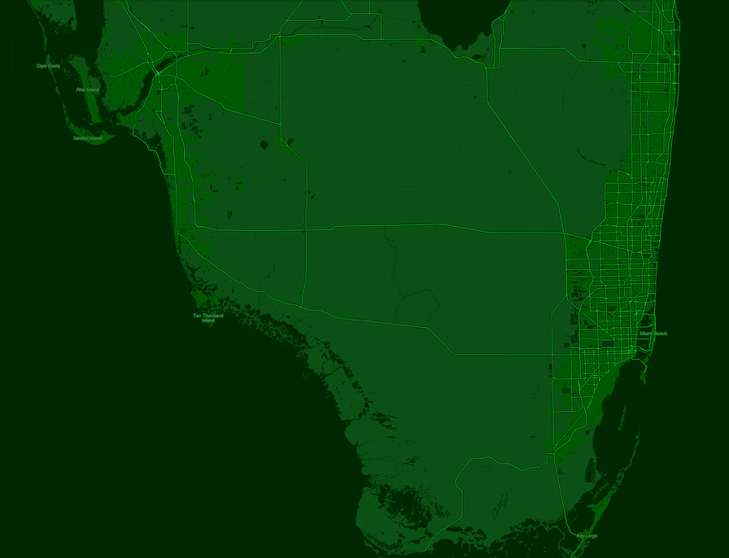

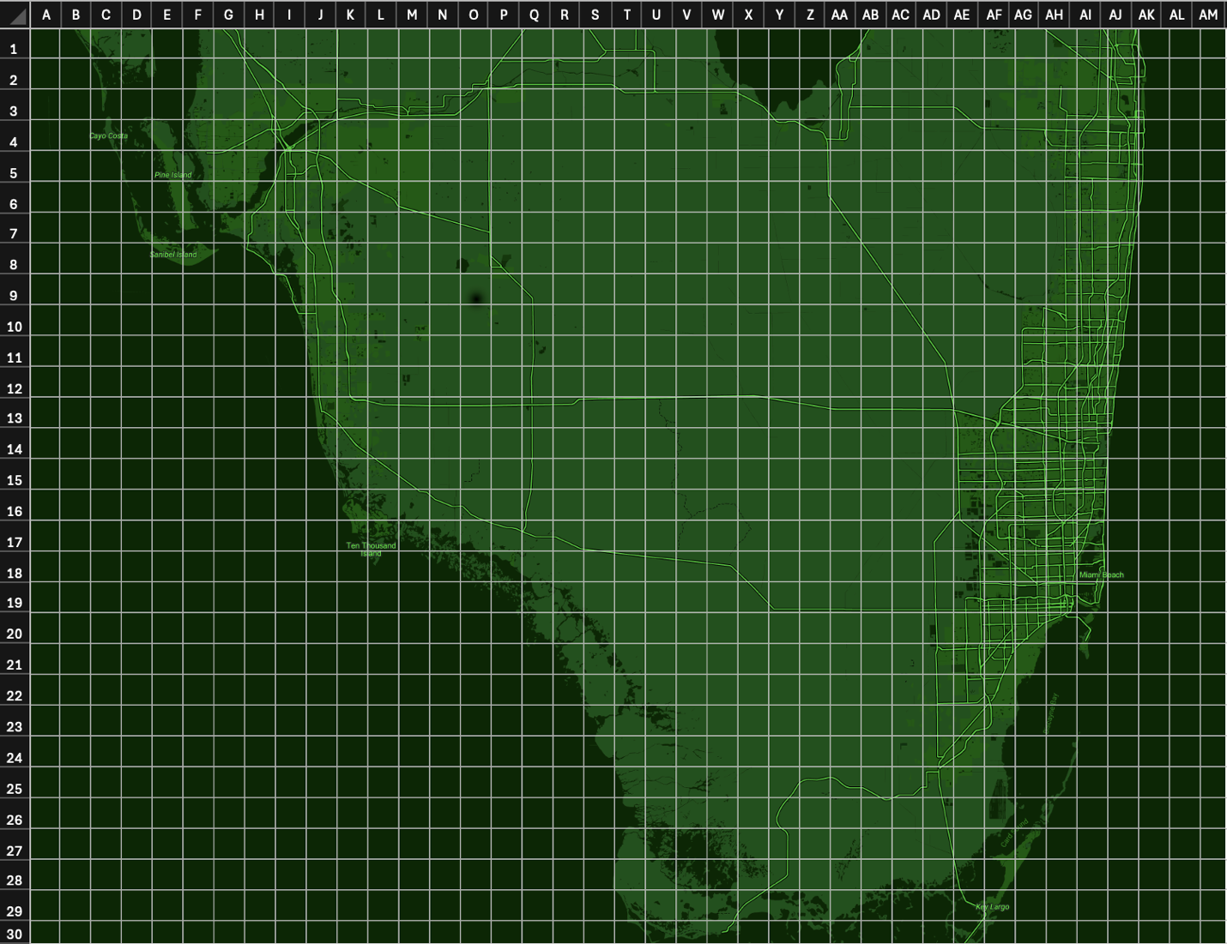

### Terrain Map

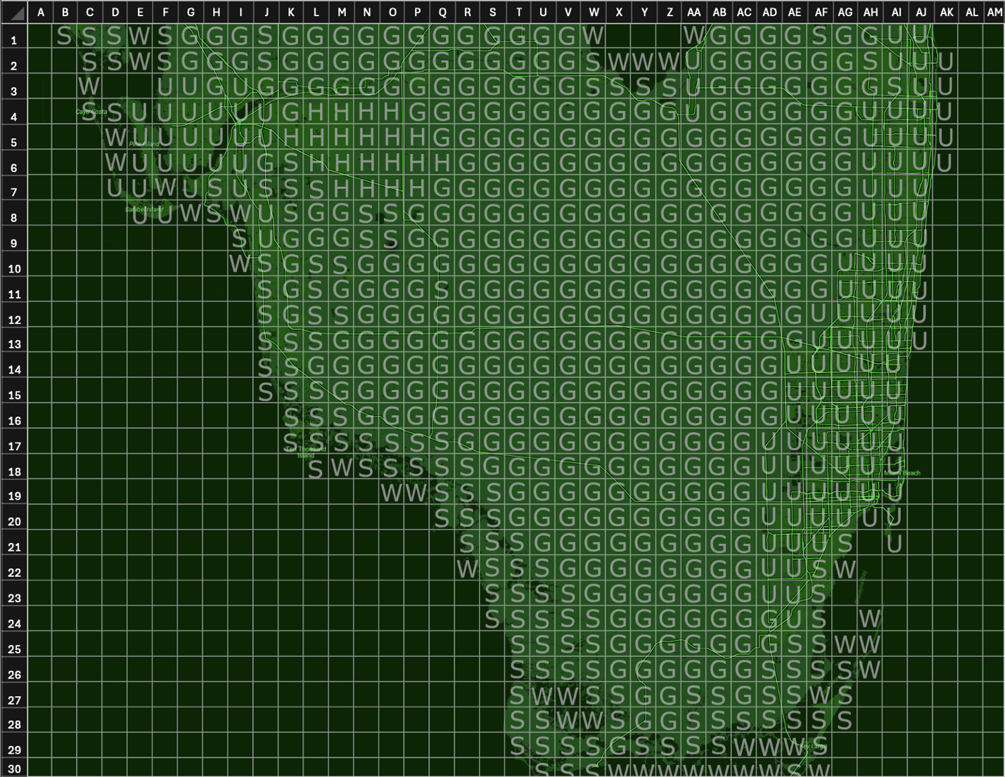

Map Legend:

* G: Grassland (standard movement speed)
* U: Urban (0.75x)
* H: Hills (0.75x)
* S: Swamp (0.5x)
* W: Shallow Water (0.25x)

Tiles with no letter are **deep water** and are untraversable.

### POI Map

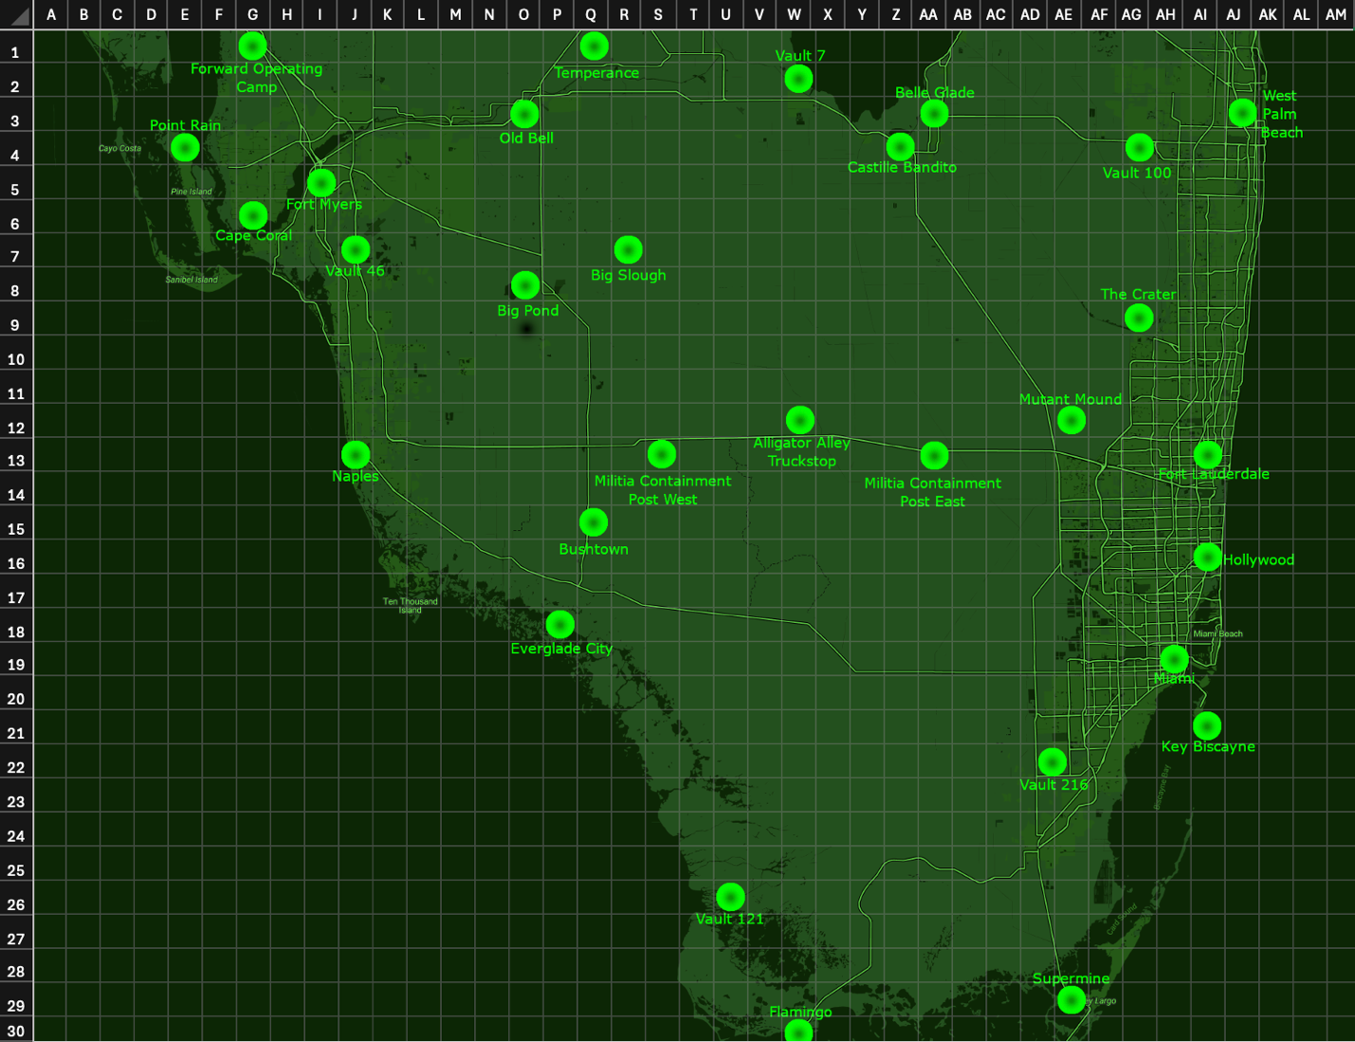

### Local Maps

#### Downtown Miami (Placeholder)

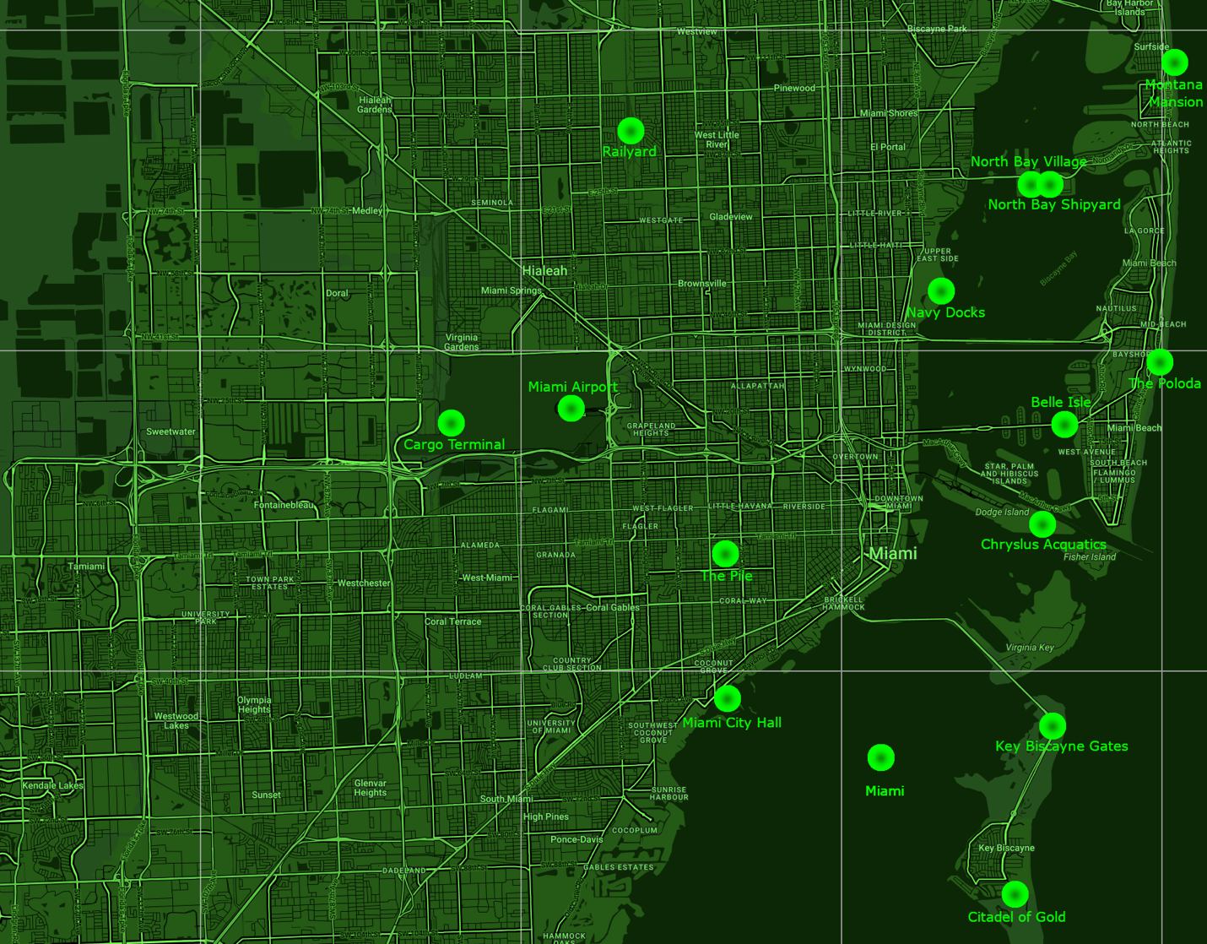

#### Hollywood (Placeholder)

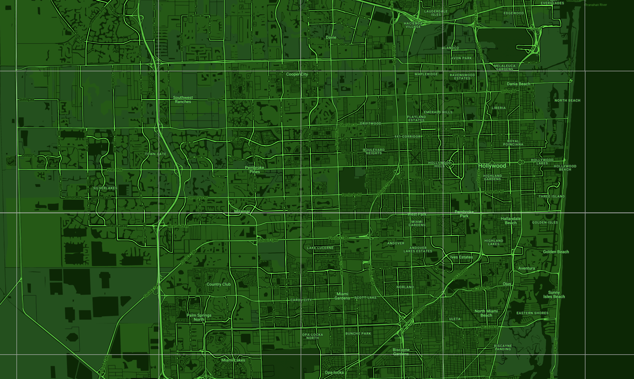

#### Fort Lauderdale (Placeholder)

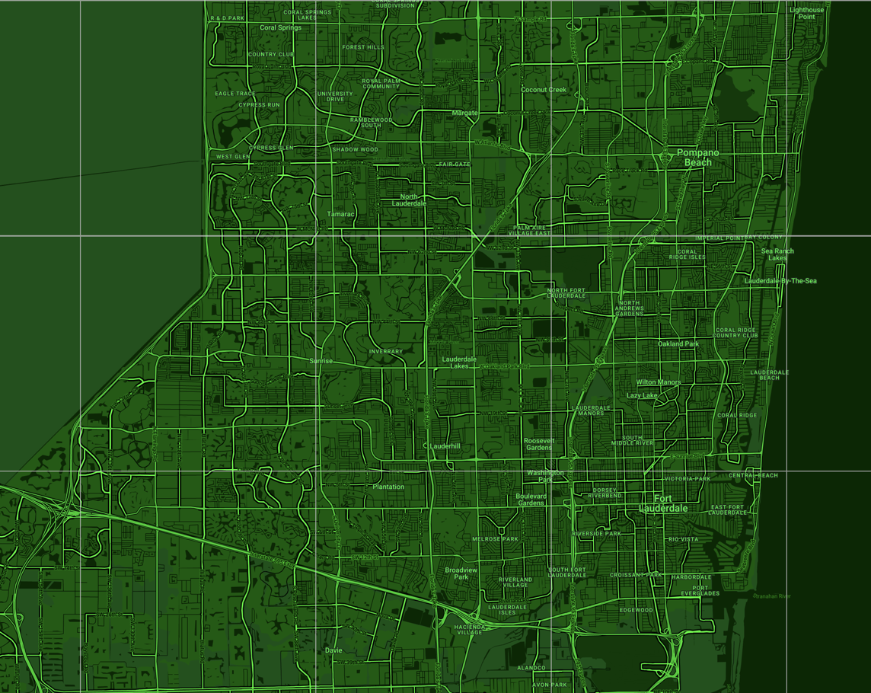

#### West Palm Beach (Placeholder)

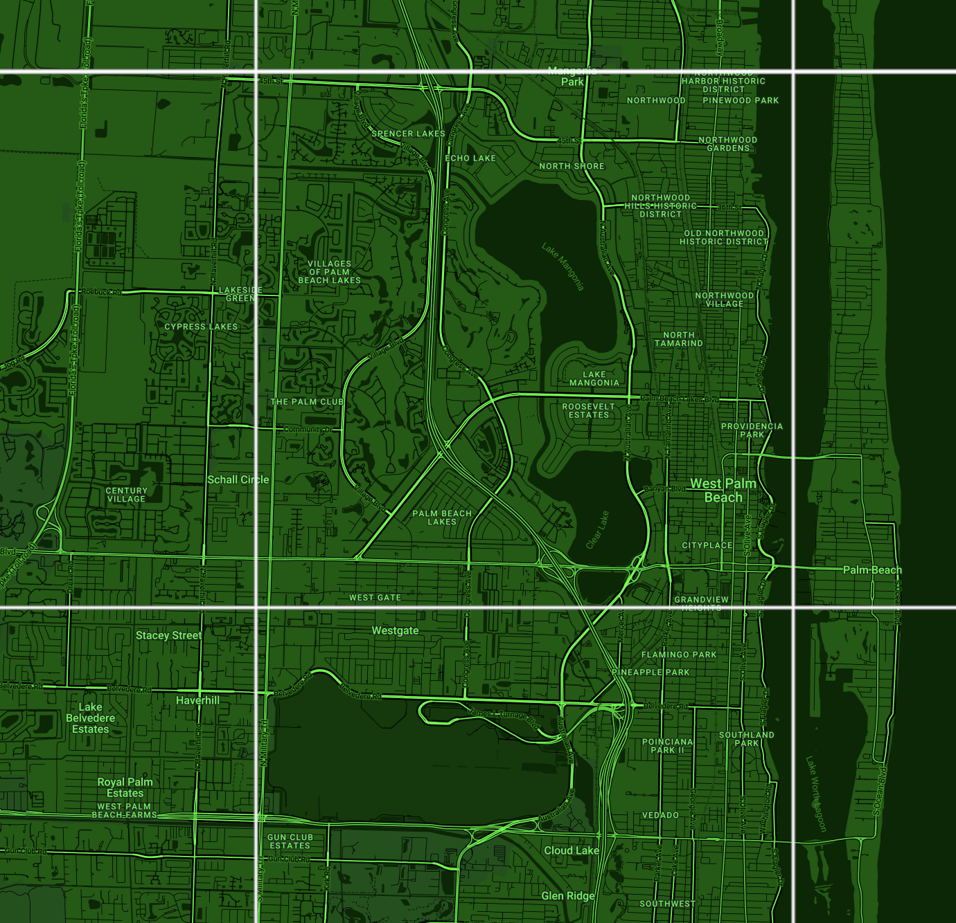

#### Fort Myers (Placeholder)

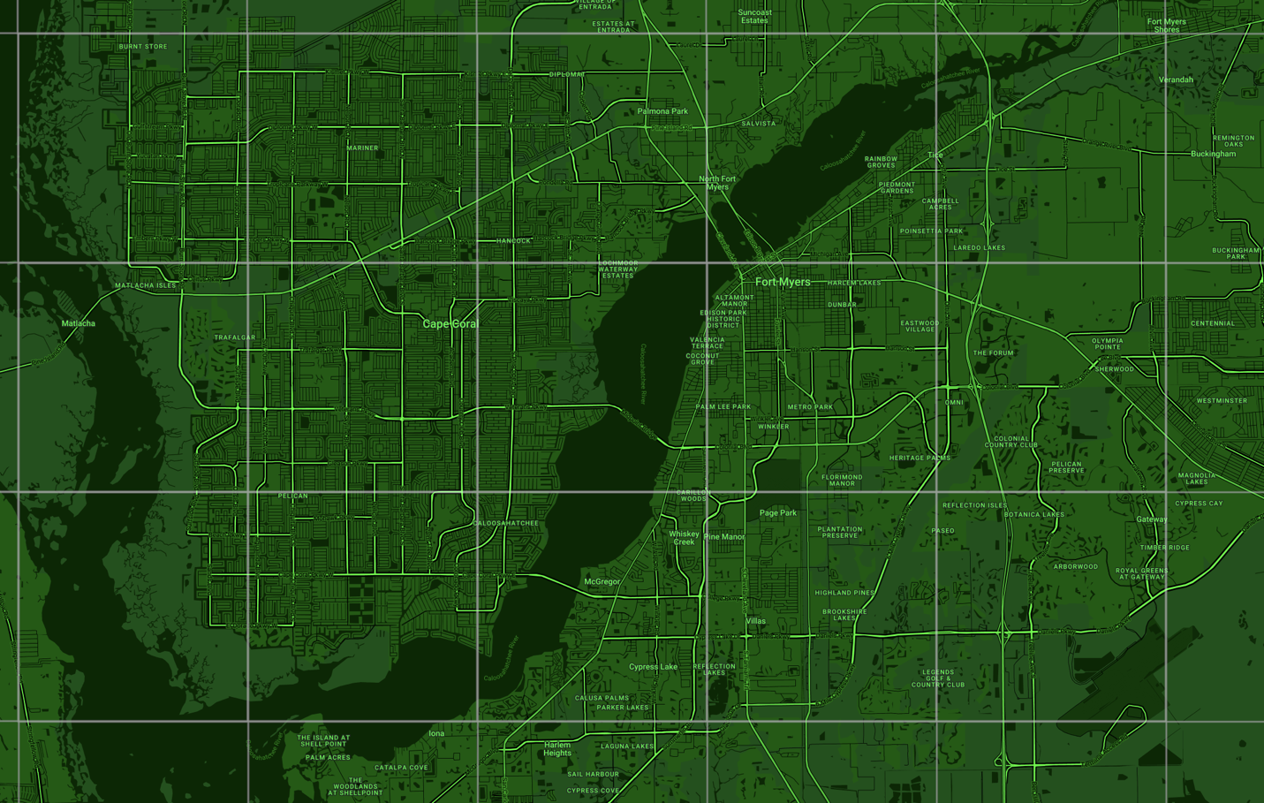

## A Brief Timeline of Events

|  |  |
| --- | --- |
| Year | Event |
| 2077 | The Great War – Global nuclear war destroys Miami, the USA, and most of the civilized world |
| 2140 | Radiation in Southern Florida begins to dissipate. Settlers from around the Southeast begin to migrate into the area. |
| 2155 | After 15 years of development, the population of the region reaches 25,000 people, with multiple large settlements |
| 2156 | Institute scouts arrive in Miami |
| 2190 | Miami Institute cuts off ties with the Commonwealth |
| 2198 | Increased presence of Miami Institute Super Mutants |
| 2256 | Brotherhood of Steel arrives in Florida |
| 2258 | BoS defectors form the Vindi Clan |
| 2269 | Brotherhood of Copper is formed at the Barnes Sound Supermine |
| 2270 | BoS leadership begins to collapse. Brotherhood of Silver forms |
| 2271 | Brotherhood of Gold formed by BoS traitors. BoS units in Vault 216 declare their independence, forming the Brotherhood of Titanium |
| 2272 | Settlers in Flamingo form the Everglade Militia |
| 2273 | Disputes in Brotherhood of Gold leadership lead to the formation of the Brotherhood of Crystal |
| 2275 | BoS imposes martial law in and around Miami. Caravan massacre occurs in the late summer |
| 2277 | Instigation by Institute forces and Enclave spies leads to all-out war between every faction in Miami. The Commonwealth Institute intervenes in an attempt to reclaim their southern counterpart – leading to massive losses in Boston and Miami. |
| 2279 | After a direct attack on the Commonwealth Institute, they retaliate – launching a full-scale nuclear attack on Florida, leading to The Collapse |
| 2280 | Armistice is organized in Downtown Miami, and new regional governments are established. A glimmer of hope for South Florida’s recovery. |
| 2291 | Small conflicts between a number of factions lead to mild instability in the region |
| 2300 | The Gunners arrive in force in Miami, causing further mayhem |
| 2310 | The year the game takes place |

## The Story of Fallout

### Pre-War America

“*War. War never changes. The Romans waged war to gather slaves and wealth. Spain built an empire from its lust for gold and territory. Hitler shaped a battered Germany into an economic superpower. But war never changes. In the 21st century, war was still waged over the resources that could be acquired. Only this time, the spoils of war were also its weapons: petroleum and uranium. For these resources, China would invade Alaska, the US would annex Canada, and the European Commonwealth would dissolve into quarreling, bickering nation-states, bent on controlling the last remaining resources on Earth.*”

* Fallout 1 Introduction

“*In the year 1945, my great-great grandfather, serving in the army, wondered when he'd get to go home to his wife and the son he'd never seen. He got his wish when the US ended World War II by dropping atomic bombs on Hiroshima and Nagasaki. The World awaited Armageddon; instead, something miraculous happened. We began to use atomic energy not as a weapon, but as a nearly limitless source of power. People enjoyed luxuries once thought the realm of science fiction. Domestic robots, fusion-powered cars, portable computers. But then, in the 21st century, people awoke from the American dream. Years of consumption lead to shortages of every major resource. The entire world unraveled. Peace became a distant memory. It is now the year 2077. We stand on the brink of total war, and I am afraid.*”

* Fallout 4 Introduction

Pre‑war America in the Fallout universe is a superpower trapped between glowing optimism and mounting anxiety: a nation that wrapped itself in the aesthetics of mid-century cheer while reorganizing every facet of life around scarcity, security, and control. On the surface, a permanent present of polished chrome, smiling mascots, and household robots. Beneath that sheen runs a harsher logic: dwindling resources, permanent mobilization, and a governing culture that treats citizens less as partners than as variables in a vast experiment in survival.

Economically, daily life is saturated with advertising and convenience goods even as the foundations of abundance erode. With conventional energy in decline, nuclear power becomes not simply an industry but a civic religion: the car in the driveway, the generator in the basement, the streetlamp on the corner – everything hums with the same radiant promise. People learn to live with contradictions: a cheerful jingle on the radio followed by a notice about shortages; a new household appliance alongside a locked cabinet of ration coupons.

Politically, emergency becomes procedure. The state centralizes authority in the name of stability, and what begins as temporary measures ossifies into default practice. Surveillance expands, now an advertised feature of public life. Loyalty campaigns and ideological tests define the boundaries of belonging, while protests are recast as threats to national survival.

Science and industry fuse into a single engine aimed at decisive advantage. Laboratories become extensions of the barracks. Robotics, materials science, and bioengineering advance with remarkable speed, but ethics lags behind, reduced to euphemism. Companies like RobCo make great advances in technology and robotics, becoming immensely powerful and asserting their will over the government. The prevailing faith is that any social problem can be engineered away if only enough power, data, and authority are applied. In this view, human variability is a flaw to be corrected rather than a condition to be governed with humility.

Domestic life is reorganized around the specter of catastrophe. Civil defense isn’t merely pamphlets and drills; it is a parallel architecture of life, with shelters, checkpoints, and contingency plans woven into the urban fabric. The message is consistent: safety is the highest good, and safety requires submission to systems that cannot be fully explained. The world’s largest corporation – Vault-Tec – capitalizes on this nuclear fear, providing secure bunkers across the country, profiting off the fear of nuclear destruction.

Abroad, the country projects the same logic that governs it at home. Competition over resources justifies a posture of permanent deployment. The United States invades and occupies Canada. The middle east collapses. The European Union descends into infighting. The language of liberation and stabilization overlays more prosaic goals of extraction and access. The result is a long, grinding tension that keeps the economy hot and the populace on edge, while steadily narrowing the range of political possibilities. War becomes less an event than an atmosphere.

Culturally, the nation doubles down on a curated version of its past: chivalric images of family, work, and community; precisely because the present feels brittle. Nostalgia performs two functions at once, comforting a stressed populace and disciplining it, channeling dissent into kitsch and recasting grievances as personal failings. The future, meanwhile, is marketed as an eternal tomorrow of better gadgets, cleaner fuel, and stronger shields. In practice, each new marvel is a tighter harness: more monitoring, more protocols, more distance between decision and consequence.

A secretive group known as the Enclave runs the nation from the shadows. A cabal of industry titans, powerful politicians, and American nationalists pull the strings, influencing the country’s actions and preparing for a post war society.

When apocalypse finally comes, it is instantaneous and total, but it is not random. It is the logical endpoint of a system that prized control over legitimacy and speed over wisdom. The tool that promised protection – nuclear fission itself – became the vector of ruin.

What survives is the lesson written into every pre‑war artifact: technology magnifies a society’s values. In this America, those values were order, purity, and dominance, pursued in the language of safety. The tragedy is not that the nation lacked ingenuity; it is that it deployed its ingenuity chiefly to tighten the coils around itself, until one terrible day the machine did exactly what it had been built to do.

### The Great War

“*The end of the world occurred pretty much as we had predicted. Too many humans, not enough space or resources to go around. The details are trivial and pointless, the reasons, as always, purely human ones. The earth was nearly wiped clean of life. A great cleansing, an atomic spark struck by human hands, quickly raged out of control. Spears of nuclear fire rained from the skies. Continents were swallowed in flames and fell beneath the boiling oceans. Humanity was almost extinguished, their spirits becoming part of the background radiation that blanketed the earth. A quiet darkness fell across the planet, lasting many years. Few survived the devastation. Some had been fortunate enough to reach safety, taking shelter in great underground vaults. When the great darkness passed, these vaults opened, and their inhabitants emerged to begin their lives again.*”

* Fallout 2 Introduction

It began in the ordinary language of a morning and ended before noon could find the right words. Sirens rose over traffic reports, contrails braided the sky, and within minutes the world’s nuclear arsenals were speaking to one another in the only grammar they had ever truly mastered. The exchange was brief, measured in hours rather than days. Systems designed to confirm, retaliate, and conclude did exactly that, faster than human caution could intervene.

Across America, the day unfolded as a sequence of impossible choices made too late. Highways locked in place as people fled in every direction at once. Shelters sealed – some protected, some failed, many simply waited. Power grids cascaded into darkness. Emergency broadcasts looped, stuttered, and died, sometimes mid‑sentence. In coastal metros and inland industrial belts alike, horizons turned to walls of light and heat. By afternoon, the nation existed mostly as memory and protocol of automated messages, unattended machinery, and pockets of people suddenly very small inside a very large silence.

Around the world, the same choreography repeated at different scales. Port cities burned like beacons. Inland corridors, chosen for rail, oil, or grain, became lines of craters. Electromagnetic pulses erased distance by erasing signal: satellites blinked out; aircraft searched for runways that no longer answered; ships at sea became islands of their own. Borders held only on maps no one could update. The wind did what wind always does, carrying the consequences. Ash fell where the models said it would, and also where they hadn’t had time to say.

By nightfall, black rain stitched the day to the days after. Firestorms fed themselves; hospitals ran on dwindling batteries; the last organized messages turned from instruction to farewell.

The war was over quickly. Its first day never ended. In a world that had built perfect machines for decisive action, the decisive action came – leaving behind a planet calibrated for speed and control, and a humanity suddenly forced to live on whatever could not be automated.

Like everyone predicted, war never changes.

### The Story of the Miami Wasteland – In Further Detail

“*Since the dawn of humankind, when our ancestors first discovered the killing power of rock and bone, blood has been spilled in the name of everything: from God to justice to simple, psychotic rage. In the year 2077, after millennia of armed conflict, the destructive nature of man could sustain itself no longer. The world was plunged into an abyss of nuclear fire and radiation. But it was not, as some had predicted, the end of the world. Instead, the apocalypse was simply the prologue to another bloody chapter of human history. For man had succeeded in destroying the world - but war, war never changes. In the early days, thousands were spared the horrors of the holocaust by taking refuge in enormous underground shelters, known as vaults. But when they emerged, they had only the hell of the wastes to greet them*”

* Fallout 3 Introduction

Following the Great War, Miami – a military-industrial stronghold – was totally decimated by atomic fire. A prime target for foreign aggression, it faced nuclear attacks on the scale of the capital. Experimental weapons were deployed, causing radioactive mutations and destruction on an unseen scale.

Until the 2130s, the area in and around Southern Florida was left totally uninhabitable, a sunken swamp of ruins, radiation, and destruction. The only forms of life in the area were mutated wildlife, and pockets of Super Mutants created by an experimental bomb dropped over Fort Lauderdale. By this time, radiation levels began to decrease and small groups of settlers from the North began to migrate downwards, stumbling upon caches of pre-war technology, resources, and horrors. By 2140, with overall safe levels of radiation, more and more settlers arrived in the area, and by 2155 thousands of people had been born or migrated – repopulating one of the most productive areas of pre-war America. Major settlements arose across the region, notably in downtown Miami, Hollywood, Fort Lauderdale, West Palm Beach, and Fort Myers. Smaller villages popped up across the wasteland, with local governments functioning simply – similar to the frontier towns of the Old West.

By 2156, word of the population growth and technological deposits in Miami had made its way up the East Coast, catching the attention of a secretive group in Boston called The Institute. A group of mostly robotic scouts were dispatched to establish a presence in the region, and by the end of the year a larger presence and permanent base of operations had been established. Regional growth continued as normal, with the Institute leeching limited amounts of technology away and dipping their toes quietly into local politics. Affairs progressed smoothly for the following years.

After more than three decades of progress and institute involvement, a new generation of leaders controlled the Miami branch of the Institute, and with them, ideals shifted. Increasingly dissatisfied with being seen as a “lesser” organization by their Boston counterparts, the Miami Institute ceased all communication with Boston and declared themselves an independent operator in 2190.

The Miami Institute began more extreme experimentation with FEV, experimental biotechnology, and cold fusion power. Dumping of FEV mixed with byproducts from other experiments would go on to pollute the water supply in the region, leading to the creation and spread of a new breed of Super Mutants which are unique to the area. This new super mutant threat would plague the region, and stunt growth, with many settlements facing large casualties in raids and wars against these roaming bands of mutants. Population growth would largely stagnate for a few decades until civilization adapted to the threat.

2256 – a century after the arrival of the Institute – saw the arrival of Miami’s next foreign faction: the Brotherhood of Steel – a techno‑monastic order, part army, part religious tech-cult. Born days before the war, from the last, disillusioned remnants of the U.S. military. The Brotherhood of Steel spread across the wasteland with heavy presence primarily on the West Coast but also more recently in the Capitol Wasteland. On their way to the East Coast, huge power signals and population were detected by systems on Brotherhood airships, and a large detachment was dispatched to investigate the source. Later that year, those troops would arrive on Pine Island (near Fort Myers), establishing a camp named Point Rain. From there, the BoS would claim settlements and technology wherever they went, eventually establishing a permanent headquarters in the strategic location of North Bay Village, a pre-war military shipyard. This pillaging of technology would increasingly conflict with the goals of the local settlers, as well as the Miami Institute – who would flee their original base of operations to a large jet, used as a mobile headquarters.

In the following years, the Brotherhood of Steel would slowly collapse into a number of splinter factions, each with their own goals and reasons for abandoning the original order. Small skirmishes would break out between the different factions, but they were mostly able to avoid full scale combat during the following two decades.

In a final attempt to hold onto authority, January 2275 would see the remnants of the Brotherhood of Steel impose a decree of martial law in the Miami area. Checkpoints were established, dissidence was cracked down upon, and wartime taxes were levied. This would lead to conflict with the Miami Government who believed the BoS had no right to take such action. This conflict would culminate in the Caravan Massacre, where a caravan transporting the Mayor and Cabinet of Miami was stopped at a checkpoint, and after a dispute, the entire caravan was brutally killed by BoS troops. It is not clear how or why the escalation occurred, or whether it was intentionally done by the BoS to claim control over the region. The massacre would lead to a war between the militias and the BoS, and the Brotherhood of Silver would get involved on the side of the militias.

After nearly two centuries of dormancy, the Miami chapter of the Enclave would receive signals from other units stationed in the Capital Wasteland, and they began small operations in Miami, stirring the pot of tension. At the same time, the Miami institute began similar operations, employing human-like synths to infiltrate wasteland factions and sow the seeds for a large-scale conflict.

2277 saw the culmination of these influences, with the assassination of the leading elders of both the BoS and the Brotherhood of Silver. Both factions would enter a brutal war with the Institute, pulling all local militias into the conflict. Spies from all factions would add fuel to the fire, leading to other brotherhood factions getting involved, with the BoG enlisting the help of other raider factions to cause further chaos. The militias, with leadership infiltrated by the Enclave and Institute, would enter the conflict and the various mercenary and criminal factions would begin combat in an attempt to gain influence in the power vacuum. This all-out combat with every faction fighting one another at one would lead to destruction and death at a scale not seen since the Great War.

In 2279, a group of Synth Coursers from Boston would ambush the leadership of the Miami Institute, in a final attempt by Boston to regain control of their former subsidiary. The Miami Institute retaliated, launching waves of attacks with experimental synths against the Institutes Boston stronghold. Boston struck back, in what became a devastating catalyst of destruction.

In November of 2279, in a last-ditch survival attempt, the Boston Institute discharged their entire suite of thermonuclear weapons on Southern Florida. Some landed, wiping settlements off the map. Some malfunctioned, leaving dud nuclear bombs scattered around the wasteland. Most were intercepted by a combined effort of Institute, Enclave, and Brotherhood anti-air defences. The impacts from the megatons of combined explosions, however, triggered a seismic event in Southern Florida, opening a ravine through the landmass, splitting the region into two distinct pieces. EMP blasts from the bombs disabled much of the technology in the region. This event, colloquially known as “The Collapse” cut the region off from all communication or contact with the rest of the world. The divide between South Florida and the mainland stretched kilometers wide of intense radiation, violent water, and mass destruction.

Shortly after the collapse (January 2280), faction leaders came together in Miami to end the destructive war which rendered the once successful region a wasteland once again. An armistice was signed, distributing territory to newly established local governments (enforced by militias), brotherhood factions, and some other mercenary or raider groups.

The region remains relatively stable for the following decade while the factions all lick their wounds, and the population is able to sustain mild recovery. Settlements rebuild, governments evolve, and business once again begins to boom. By the 2290s, raider groups had once again begun to encroach on settlements, and a small but bloody conflict between the Brotherhood of Silver and Brotherhood of Gold led to the razing of a settlement named Big Pond in 2291. Southern Florida, while safer, was still a region plagued by political instability and war. Under the new militia government, Miami saw steady growth, with almost every building in the downtown core now fully inhabited. Economic development saw entire city blocks rebuilt into functional multi-story housing, and bustling markets and neighborhoods arose from the ashes of the destroyed city.

Naturally, other threats arose and died out throughout the years, notably a group called the Gunners were the first ones to make the perilous journey across the collapse around 2300, but progress in Miami and Florida has continued into the present, even though they are almost fully separated from the rest of the wasteland.

### 2310

The year 2310 introduced a number of catalysts which again shifted the balance of power in and around Miami.

Hundreds have died in the streets of cities at the hands of a new chem developed by the Brotherhood of Crystal – purple glass. Extremely potent, extremely deadly, and extremely addictive, it is making its way throughout the wasteland and completely halting growth at certain settlements, leading to militias cracking down to thwart the Brotherhood of Crystal and their network of chem dealers.

The gunners, now with a full-scale base of operations at the Chryslus Stadium have launched various merciless attacks against settlements, factions, factories, and traders – all at the hands of whoever the highest paying client in the wasteland is.

After decades of preparation, the Enclave have begun boots-on-the-ground operations in Miami. With the location of their main operating base still unknown, they’ve managed to insert a small but tough presence in and around the cities of Southern Florida, attacking mutants, inciting violence, and observing the development of wastelanders. While their intentions are still unknown, stories of their atrocities and actions on the West Coast and in the Capitol Wasteland leave locals in a state of fear of what is to come.

The Brotherhood of Steel remnants, now a shell of their once great order, have begun a migration northward from Miami, setting up camps above West Palm Beach, in what appears to be an attempt to cross The Collapse. Wastelanders theorize what their intentions could be, whether it is escaping the region, reestablishing contact with the other Brotherhood of Steel elders, or creating a supply line to the rest of the wasteland.

This turmoiled but opportune situation leaves us in the present, with a party of (or maybe just one) wastelanders embarking on an adventure to explore the Miami Wasteland. Will they alter the outcome of the entire Miami regions’ history? Or will the succumb to the scourges of the wasteland? Only time will tell…

# Appendixes

## Appendix A: Items

Items are sorted first by type, and then further subdivided differently depending on their type. Items will be listed alphabetically.

### Weapons

A brief overview of how weapon items are listed:

Weapon Name

* Damage | Damage Type
  + - Ammo Type
  + Modification Slots
    - * Other Effects/Modifiers

#### Ballistic Weapons

##### Long Guns

Anti-Material Rifle

* 1d20 | Ballistic Damage
  + - .50 MG
  + Bottom, Grip, Optic, Side, Stock

Assault Carbine

* 4d6 | Ballistic Damage
  + - 5.56mm
  + Bottom, Foregrip, Grip, Muzzle, Optic, Side, Stock, Top

Assault Rifle

* 3d6 | Ballistic Damage
  + - 5.56mm
  + Bottom, Foregrip, Grip, Muzzle, Optic, Side, Stock, Top

Battle Rifle

* 2d10 | Ballistic Damage
  + - .308 Winchester
    - Foregrip, Muzzle, Optic,

BB Gun

* 1d2 | Ballistic Damage
  + - Plastic BB

Chinese Assault Rifle

* 2d6 | Ballistic Damage
  + - 5.56mm
  + Foregrip, Grip, Muzzle, Optic, Side, Stock,

Combat Rifle

* 4d6 | Ballistic Damage
  + - 7.62mm
  + Bottom, Foregrip, Grip, Muzzle, Optic, Side, Stock, Top

Gauss Rifle

* 1d20 | Ballistic Damage
  + - 2mm EC
  + Foregrip, Grip, Optic

Grease Gun

* 3d4 | Ballistic Damage
  + - .45 ACP
  + Bottom, Foregrip, Grip, Muzzle, Stock, Top

HK G11

* 6d6 | Ballistic Damage
  + - 4.7mm Caseless
  + Bottom, Grip, Muzzle, Stock, Top

Hunting Rifle

* 1d8 | Ballistic Damage
  + - .223 Remington
  + Grip, Muzzle, Optic

Lever Action Repeater

* 2d6 | Ballistic Damage
  + - 10mm
  + Foregrip, Optic, Stock

Light Machine Gun

* 10d4 | Ballistic Damage
  + - 5.56mm
  + Bottom, Grip, Muzzle, Optic, Stock

Power Armour Assault Rifle

* 3d10 | Ballistic Damage
  + - 7.62mm
  + Foregrip, Grip, Muzzle, Optic, Stock, Top

P90

* 6d4 | Ballistic Damage
  + - 9mm

Railway Rifle

* 1d12 | Impact Damage
  + - Railway Spike
  + Optic, Stock

Service Rifle

* 2d6 | Ballistic Damage
  + - 5.56mm
  + Bottom, Foregrip, Grip, Muzzle, Optic, Side, Stock, Top

Silenced SMG

* 3d4 | Ballistic Damage
  + - .22 LR
  + Foregrip, Grip, Optic, Side, Stock

Sniper Rifle

* 1d12 | Ballistic Damage
  + - 7.62mm
  + Bottom, Grip, Optic, Side, Stock

Suppressed Sniper Rifle

* 1d12 | Ballistic Damage
  + - 7.62mm
  + Bottom, Grip, Optic, Side, Stock

Syringer

* 1d10 | Healing
  + - Syringer Cartridges

Tommy Gun

* 6d4 | Ballistic Damage
  + - .45 ACP
  + Bottom, Foregrip, Grip, Muzzle, Optic, Side, Stock, Top

Trail Carbine

* 2d6 | Ballistic Damage
  + - .44 Magnum
  + Foregrip, Optic, Stock

Varmint Rifle

* 3d4 | Ballistic Damage
  + - .22 LR
  + Foregrip, Optic, Stock

XL70E3

* 4d8 | Ballistic Damage
  + - 5mm
  + Optic

10mm SMG

* 5d4 | Ballistic Damage
  + - 10mm
  + Bottom, Foregrip, Grip, Muzzle, Optic, Top

##### Short Guns

Chinese Pistol

* 2d4 | Ballistic Damage
  + - 10mm
  + Bottom, Grip, Muzzle, Optic

Dart Gun

* 1d4 | Ballistic Damage
  + - Darts
  + Grip, Optic
    - * Inflicts Poison

Deliverer Pistol

* 2d6 | Ballistic Damage
  + - 10mm
  + Bottom, Grip, Muzzle

Desert Eagle

* 1d12 | Ballistic Damage
  + - .44 Magnum
  + Bottom, Grip

Flare Gun

* 1d4 | Fire Damage
  + - Flares

Mauser Pistol

* 2d6 | Ballistic Damage
  + - 9mm
  + Grip, Muzzle

Needler Pistol

* 1d6 | Healing
  + - Syringer Cartridges

Power Armour 10mm Pistol

* 2d6 | Ballistic Damage
  + - 10mm
  + Bottom, Grip, Muzzle, Optic, Top

PPK12 Gauss Pistol

* 1d12 | Ballistic Damage
  + - 2mm EC
  + Grip, Stock

10mm Pistol

* 4d4 | Ballistic Damage
  + - 10mm
  + Bottom, Grip, Muzzle, Optic

12.7mm Pistol

* 4d4 | Ballistic Damage
  + - 12.7mm
  + Bottom, Grip, Muzzle

14mm Pistol

* 6d4 | Ballistic Damage
  + - 14mm
  + Bottom, Foregrip, Grip, Muzzle, Optic

.223 Pistol

* 4d6 | Ballistic Damage
  + - .223 Remington
  + Bottom, Foregrip, Grip, Muzzle

.32 Revolver

* 2d4 | Ballistic Damage
  + - .32 ACP
  + Grip

.357 Magnum

* 2d6 | Ballistic Damage
  + - .357 Magnum
  + Grip

.44 Magnum

* 2d8 | Ballistic Damage
  + - .44 Magnum
  + Bottom, Grip

.45 Pistol

* 3d6 | Ballistic Damage
  + - .45 ACP
  + Bottom, Grip, Muzzle

9mm Pistol

* 2d6 | Ballistic Damage
  + - 9mm
  + Bottom, Grip, Muzzle

##### Shotguns

Caravan Shotgun

* 1d10 | Ballistic Damage
  + - 20 Gauge Shells, 20 Gauge Slugs
  + Grip, Stock

Combat Shotgun

* 3d10 | Ballistic Damage
  + - 12 Gauge Shells, 12 Gauge Slugs
  + Bottom, Foregrip, Grip, Muzzle, Optic, Side, Stock,

Double Barrel Shotgun

* 2d8 | Ballistic Damage
  + - 12 Gauge Shells, 12 Gauge Slugs
  + Grip, Stock

H&K CAWS

* 3d10 | Ballistic Damage
  + - 12 Gauge Shells, 12 Gauge Slugs

Jackhammer

* 2d12 | Ballistic Damage
  + - 12 Gauge Shells, 12 Gauge Slugs
  + Grip, Optic

Lever-Action Shotgun

* 2d10 | Ballistic Damage
  + - 20 Gauge Shells, 20 Gauge Slugs
  + Grip, Stock

Pump-Action Shotgun

* 3d10 | Ballistic Damage
  + - 12 Gauge Shells, 12 Gauge Slugs
  + Foregrip, Grip, Optic, Stock

Riot Shotgun

* 4d12 | Ballistic Damage
  + - 12 Gauge Shells, 12 Gauge Slugs
  + Bottom, Foregrip, Grip, Muzzle, Optic, Side, Stock, Top

Sawed-off Shotgun

* 2d8 | Ballistic Damage
  + - 12 Gauge Shells, 12 Gauge Slugs
  + Grip

##### Heavy Weapons

Cryolater

* 1d12 | True Damage
  + - Cryolater Fuel
  + Foregrip, Grip, Optic
    - * 50% Chance to inflict paralysis

Fat Man

* 10d20 | Radiation Damage
  + - Mini Nuke
  + Optic, Special Mod
    - * Causes a 12-tile explosion on impact

Flamer

* 2d12 | Fire Damage
  + - Flamer Fuel
  + Foregrip, Grip, Optic, Special Mod

Harpoon Gun

* 1d20 | Ballistic Damage
  + - Harpoon
      * Allows you to move enemy 3 tiles closer to you

Heavy Incinerator

* 2d20 | Fire Damage
  + - Flamer Fuel
  + Optic

Heavy Machine Gun

* 6d8 | Ballistic Damage
  + - 7.62mm
  + Bottom, Foregrip, Grip, Muzzle, Optic, Stock, Top

Junk Jet

* 1d20 | Impact Damage
  + - Any junk item
  + Optic, Stock

Minigun

* 5d12 | Ballistic Damage
  + - 5mm

Missile Launcher

* 2d20 | Ballistic Damage
  + - Missile
  + Optic
    - * Causes a 5-tile radius explosion upon impact

#### Energy Weapons

##### Long Guns

Alien Disintegrator

* 3d10 | Radiation Damage
  + - Alien Energy Cell
  + Grip, Optic

Institute Rifle

* 4d6 | Laser Damage
  + - Microfusion Cell
  + Bottom, Foregrip, Grip, Muzzle, Optic, Side, Stock, Top

Laser Musket

* 1d12 | Laser Damage
  + - Energy Cell
  + Bottom, Grip, Optic, Stock

Laser Rifle

* 3d6 | Laser Damage
  + - Microfusion Cell
  + Bottom, Foregrip, Grip, Muzzle, Optic, Side, Stock

Miami Institute Rifle

* 3d8 | Laser Damage
  + - Microfusion Cell
  + Bottom, Foregrip, Grip, Muzzle, Side, Stock, Top

Multiplas Rifle

* 1d20 | Plasma Damage
  + - Energy Cell
  + Foregrip, Grip, Muzzle, Optic, Stock

Plasma Rifle

* 3d8 | Plasma Damage
  + - Microfusion Cell
  + Foregrip, Grip, Muzzle, Optic, Stock

Pulse Rifle

* 1d8 | Radiation Damage
  + - Microfusion Cell
  + Optic

Recharger Rifle

* 3d4 | Laser Damage
  + - Microfusion Breeder
  + Grip, Muzzle, Optic, Side, Stock, Top

Tesla Rifle

* 4d6 | Electric Damage
  + - 1.5% Fusion Core
  + Optic

Tri-Beam Laser Rifle

* 1d12 | Laser Damage
  + - Energy Cell
  + Bottom, Foregrip, Grip, Muzzle, Optic, Side, Stock

##### Short Guns

Alien Pistol

* 3d6| Radiation Damage
  + - Alien Energy Cell
  + Grip, Optic

Institute Pistol

* 4d4 | Laser Damage
  + - Microfusion Cell
  + Bottom, Grip, Muzzle, Optic, Side, Stock, Top

Laser Pistol

* 3d4 | Laser Damage
  + - Microfusion Cell
  + Bottom, Grip, Muzzle, Optic, Side

Miami Institute Pistol

* 3d6 | Laser Damage
  + - Microfusion Cell
  + Bottom, Grip, Muzzle, Side, Top

Plasma Defender

* 4d6 | Plasma Damage
  + - Microfusion Cell
  + Bottom, Grip, Muzzle, Optic, Side, Stock

Plasma Pistol

* 3d6 | Plasma Damage
  + - Microfusion Cell
  + Bottom, Grip, Muzzle, Optic, Stock

Recharger Rifle

* 2d4 | Laser Damage
  + - Microfusion Breeder
  + Grip, Muzzle, Optic, Side

Sonic Emitter

* 2d6 | True Damage
  + - Microfusion Breeder
  + Grip, Optic

Tri-Beam Laser Pistol

* 1d8 | Laser Damage
  + - Energy Cell
  + Bottom, Grip, Muzzle, Optic, Side

##### Heavy Weapons

Gatling Laser

* 7d6 | Laser Damage
  + - Energy Cell
  + Grip

Institute Eviscerator

* 4d8| Laser Damage
  + - 0.5% Fusion Core
  + Foregrip, Grip, Muzzle, Optic, Stock

Plasma Caster

* 2d12 | Plasma Damage
  + - Energy Cell
  + Grip, Optic, Stock

Tesla Cannon

* 2d20 | Electric Damage
  + - Energy Cell
  + Foregrip, Grip, Optic, Stock

#### Pipe Weapons

Pipe Shotgun

* Ballistic Damage

Pipe Rifle

* Ballistic Damage

Pipe Sniper Rifle

* Ballistic Damage

Pipe Pistol

* Ballistic Damage

Pipe Sub-Machine Gun

* Ballistic Damage

#### Melee Weapons

##### Small Melee Weapons (1 tile range)

Axe

* 1d10 | Impact Damage

Baton

* 1d6 | Impact Damage

Brass Knuckles

* 1d4 | Impact Damage

Cattle Prod

* 1d8 | Electric Damage

Chainsaw

* 2d10 | Slashing Damage

Chinese Officer’s Sword

* 1d10 | Slashing Damage

Cleaver

* 1d6 | Slashing Damage

Combat Knife

* 1d6 | Slashing Damage

Hatchet

* 1d6 | Impact Damage

Knife

* 1d4 | Slashing Damage

Lead Pipe

* 1d6 | Impact Damage

Machete

* 1d6 | Slashing Damage

Power Fist

* 1d20 | Impact Damage

Ripper

* 2d12 | Slashing Damage

Shishkebab

* 1d12 | Slashing Damage
  + - * 33% Chance to inflict fire

Shiv

* 1d4 | Slashing Damage

Spear

* 1d6 | Slashing Damage

Spiked Knuckles

* 1d6 | Impact Damage

Switchblade

* 1d4 | Slashing Damage

Tire Iron

* 1d6 | Impact Damage

Wrench

* 1d6 | Impact Damage

##### Large Melee Weapons (2 tile range)

Auto Axe

* 2d8 | Slashing Damage

Baseball Bat

* 1d10 | Impact Damage

Battle Axe

* 1d20 | Impact Damage

Board

* 1d4 | Impact Damage

Crowbar

* 1d6 | Impact Damage

Golf Club

* 1d4 | Impact Damage

Nail Board

* 2d4 | Impact Damage

Pool Cue

* 1d4 | Impact Damage

Rebar Club

* 1d8 | Impact Damage

Sledgehammer

* 1d8 | Impact Damage

Stake

* 1d10 | Impact Damage

Super Sledge

* 2d8 | Impact Damage

#### Explosives and Throwables

Cryo Grenade (E)

* 1d12 | True Damage
  + - * Inflicts paralysis

Cryo Mine (E)

* 1d12 | True Damage
  + - * Inflicts paralysis

Dynamite (E)

* Impact Damage

Flare

* Fire Damage

Fragmentation Grenade (E)

* Ballistic Damage

Fragmentation Mine (E)

* Ballistic Damage

Flashbang

* + - * 80% chance to blind enemies for 2 turns

Gas Canister

* True Damage
  + - * 75% chance to inflict poison

Incendiary Grenade (E)

* Fire Damage

Molotov

* Fire Damage

Nuka Grenade (E)

* Radiation Damage

Plasma Grenade (E)

* Plasma Damage

Plasma Mine (E)

* Plasma Damage

Plastic Explosives (E)

* Impact Damage

Pulse Grenade

* 1d8 | Electric Damage
  + - * Disables robotics and electronics

Satchel Charge (E)

* Impact Damage

Throwing Axe

* 1d10 | Slashing Damage

Throwing Knife

* 1d8 | Slashing Damage

Throwing Spear

* 1d8 | Slashing Damage

### Ammunition

#### Ballistic Weapons

* Cryolater Fuel
* Darts
* Flamer Fuel
* Flares
* Harpoon
* Mini Nuke
* Missile
* Plastic BB
* Railway Spike
* Syringer Cartridges
* 10mm
* 12 Gauge Shells
* 12 Gauge Slugs
* 12.7mm
* 14mm
* 2mm Electromagnetic Cartridge
* 20 Gauge Shells
* 20 Gauge Slugs
* .22 LR
* .223 Remington
* .308 Winchester
* .32 ACP
* .357 Magnum
* .44 Magnum
* .45 ACP
* 4.7mm Caseless
* 5mm
* .50 MG
* 5.56mm
* 7.62mm
* 9mm

#### Energy Weapons

* Alien Energy Cell
* Microfusion Cell
* Energy Cell
* Microfusion Breeder
* Fusion core

### Apparel

A brief overview of how apparel items are listed:

Apparel Name

* SPECIAL Modifiers
  + - Damage Resistance
  + Modification Slots
    - * Other Effects/Modifiers

#### Armour

BoCr Armoured Suit

* + - 30% Damage Resistance
  + Left Shoulder, Right Shoulder

BoG Raider Armour

* + - 35% Damage Resistance
  + Chest, Left Shoulder, Right Shoulder, Waist

BOS Soldier Armour

* + - 30% Damage Resistance
  + Back, Chest, Left Shoulder, Right Shoulder

BoSi Combat Armour

* + - 30% Damage Resistance
  + Back, Chest, Left Shoulder, Right Shoulder, Waist

BoT Vault Armour

* + - 40% Damage Resistance
  + Back, Chest, Waist

Cartel Armour

* + - 20% Damage Resistance
  + Back, Waist

Chinese Stealth Armour

* + - 20% Damage Resistance
      * Acts as a stealth boy on command.

Combat Armour

* + - 30% Damage Resistance
  + Back, Chest, Left Shoulder, Right Shoulder, Waist

Enclave Combat Suit

* + - 40% Damage Resistance
  + Left Shoulder, Right Shoulder, Waist
    - * Take 10% less Rads. Purifies drinking water.

Gunners Armour

* + - 40% Damage Resistance
  + Modification Slots

Leather Armour

* + - 10% Damage Resistance
  + Back, Waist

Merc Gear

* + - 20% Damage Resistance
  + Back, Chest, Waist
    - * Take 5% less Rads.

Militia Armour

* + - 20% Damage Resistance
  + Back, Chest, Left Shoulder, Right Shoulder

Metal Armour

* + - 25% Damage Resistance
  + Left Shoulder, Right Shoulder

Raider Armour

* + - 20% Damage Resistance
  + Back, Chest

Raider Commando Armour

* + - 30% Damage Resistance
  + Back, Chest, Left Shoulder, Right Shoulder

Synth Armour

* + - 30% Damage Resistance
      * 5% Bonus energy weapon damage resistance.

Tesla Armour

* + - 30% Damage Resistance
  + Back, Chest
    - * 25% chance to deal 1d6 electric damage when melee attacked.

Vault Security Armour

* + - 20% Damage Resistance
  + Back, Chest, Waist

#### Clothing

Brotherhood Fatigues

* +1 Endurance, +1 Intelligence
  + Waist

Brotherhood Initiate Robe

* +1 Intelligence

Brotherhood Scribe Robe

* +1 Perception, +3 Intelligence
  + Waist

Brotherhood Technician Uniform

* +1 Intelligence, +1 Agility
  + Back, Waist

Fancy Suit

* +2 Charisma, +1 Intelligence

Flight Suit

* +3 Perception, +2 Agility

Formal Wear

* +3 Luck

Formal Wear – Fancy

* +5 Luck

Formal Wear – Lucky

* +7 Luck

Gunners Harness

* +2 Endurance
* Back, Left Shoulder, Right Shoulder, Waist

Jumpsuit – Handyman

* +3 Agility

Jumpsuit – Advanced

* +5 Agility

Jumpsuit – Expert

* +7 Agility

Institute Jumper

* +4 Intelligence, +1 Agility

Lab Coat

* +3 Intelligence

Lab Coat – Advanced

* +5 Intelligence

Lab Coat – Expert

* +7 Intelligence

Medic Gear

* +1 Perception, +1 Intelligence, +1 Agility

Miami Institute Jumper

* +4 Intelligence, +2 Agility, +1 Luck

Military Fatigues

* +3 Strength

Military Fatigues – Officer

* +5 Strength

Military Fatigues – Commander

* +7 Strength

Nightwear

* +3 Charisma

Nightwear – Naughty

* +5 Charisma

Nightwear – Lucky

* +7 Charisma

Officer Uniform

* +3 Charisma, +3 Intelligence

Radiation Suit

* +3 Endurance

Radiation Suit – Advanced

* +5 Endurance

Radiation Suit – Expert

* +7 Endurance

Soldier Uniform

* +3 Strength, +3 Agility

Vault Suit

* +1 SPECIAL

Wasteland Gear

* +3 Perception

Wasteland Gear – Sturdy

* +5 Perception

Wasteland Gear – Heavy

* +7 Perception

#### Power Armour

T-45 Power Armour

* +3 Strength, +2 Endurance, -1 Agility
  + - 10% Damage Resistance
  + Helmet, Left Arm, Left Leg, Right Arm, Right Leg
    - * Enables V.A.T.S.

T-45a Power Armour

* +3 Strength, +2 Endurance, -1 Agility
  + - 10% Damage Resistance
  + Helmet, Left Arm, Left Leg, Right Arm, Right Leg, Torso
    - * Enables V.A.T.S.

T-45b Power Armour

* +3 Strength, +2 Endurance, -1 Agility
  + - 15% Damage Resistance
  + Helmet, Left Arm, Left Leg, Right Arm, Right Leg, Torso
    - * Enables V.A.T.S.

T-45c Power Armour

* +3 Strength, +3 Endurance, -1 Agility
  + - 15% Damage Resistance
  + Helmet, Left Arm, Left Leg, Right Arm, Right Leg, Torso
    - * Enables V.A.T.S.

T-45d Power Armour

* +3 Strength, +3 Endurance, -1 Agility
  + - 20% Damage Resistance
  + Helmet, Left Arm, Left Leg, Right Arm, Right Leg, Torso
    - * 25% Radiation Resistance, Enables V.A.T.S.

T-51 Power Armour

* +3 Strength, +2 Perception, +2 Endurance, -1 Agility
  + - 20% Damage Resistance
  + Helmet, Left Arm, Left Leg, Right Arm, Right Leg, Torso
    - * Enables V.A.T.S.

T-51a Power Armour

* +3 Strength, +2 Perception, +2 Endurance
  + - 20% Damage Resistance
  + Helmet, Left Arm, Left Leg, Right Arm, Right Leg, Torso
    - * Enables V.A.T.S.

T-51b Power Armour

* +3 Strength, +2 Perception, +3 Endurance
  + - 20% Damage Resistance
  + Helmet, Left Arm, Left Leg, Right Arm, Right Leg, Torso
    - * 50% Radiation Resistance, Enables V.A.T.S.

T-51c Power Armour

* +3 Strength, +2 Perception, +3 Endurance
  + - 25% Damage Resistance
  + Helmet, Left Arm, Left Leg, Right Arm, Right Leg, Torso
    - * 50% Radiation Resistance, Enables V.A.T.S.

T-51d Power Armour

* +3 Strength, +2 Perception, +3 Endurance
  + - 25% Damage Resistance
  + Helmet, Left Arm, Left Leg, Right Arm, Right Leg, Torso
    - * 100% Radiation Resistance, Enables V.A.T.S.

T-60 Power Armour

* +3 Strength, +3 Perception, +3 Endurance
  + - 30% Damage Resistance
  + Helmet, Left Arm, Left Leg, Right Arm, Right Leg, Torso
    - * 50% Radiation Resistance, Enables V.A.T.S.

T-60a Power Armour

* +3 Strength, +3 Perception, +3 Endurance
  + - 30% Damage Resistance
  + Helmet, Left Arm, Left Leg, Right Arm, Right Leg, Torso
    - * 100% Radiation Resistance, Enables V.A.T.S.

T-60b Power Armour

* +3 Strength, +3 Perception, +3 Endurance, +1 Agility
  + - 30% Damage Resistance
  + Helmet, Left Arm, Left Leg, Right Arm, Right Leg, Torso
    - * 100% Radiation Resistance, Enables V.A.T.S.

T-60c Power Armour

* +3 Strength, +3 Perception, +3 Endurance, +1 Agility
  + - 35% Damage Resistance
  + Helmet, Left Arm, Left Leg, Right Arm, Right Leg, Torso
    - * 100% Radiation Resistance, Enables V.A.T.S.

T-60d Power Armour

* +3 Strength, +3 Perception, +3 Endurance, +1 Agility
  + - 40% Damage Resistance
  + Helmet, Left Arm, Left Leg, Right Arm, Right Leg, Torso
    - * 100% Radiation Resistance, Enables V.A.T.S.

T-60e Power Armour

* +4 Strength, +4 Perception, +3 Endurance, +2 Agility
  + - 45% Damage Resistance
  + Helmet, Left Arm, Left Leg, Right Arm, Right Leg, Torso
    - * 100% Radiation Resistance, Enables V.A.T.S.

X-01 Power Armour

* +3 Strength, +3 Perception, +3 Endurance, +3 Intelligence, +3 Agility
  + - 40% Damage Resistance
      * 100% Radiation Resistance, Enables V.A.T.S.

X-01 mk1 Power Armour

* +3 Strength, +3 Perception, +3 Endurance, +3 Intelligence, +3 Agility
  + - 40% Damage Resistance
      * 100% Radiation Resistance, Enables V.A.T.S.

X-01 mk2 Power Armour

* +3 SPECIAL
  + - 50% Damage Resistance
  + Helmet, Left Arm, Left Leg, Right Arm, Right Leg, Torso
    - * 100% Radiation Resistance, Enables V.A.T.S.

Hellfire Power Armour

* +3 Strength, +3 Perception, +3 Endurance, +3 Intelligence, +3 Agility
  + - 40% Damage Resistance
  + Helmet, Torso
    - * 100% Radiation Resistance, 50% Fire Damage Resistance, Enables V.A.T.S.

### Aid

#### Alcohol

Beer

* +1 Strength, +1 Charisma, -1 Intelligence (120 Seconds)

Bourbon

* +2 Strength, +2 Endurance, -1 Intelligence (100 seconds)

Dirty Wastelander

* +3 Strength, +1 Charisma, -2 Intelligence, (60 seconds)

Nuka-Cola Dark

* 1d10 HP, +1 Rads, +1 Strength, +1 Charisma, -1 Intelligence (60 seconds)

Nuka-Cola Dark (Ice Cold)

* 1d10 HP, +1 Rads, +1 Strength, +1 Charisma -1 Intelligence (90 seconds)

Palm Ale

* +1 Strength, +1 Charisma, -1 Intelligence, -1 Luck (120 seconds)

Palm Brew

* +1 Strength, +1 Charisma, -1 Intelligence, -1 Luck (120 seconds)

Palm Lager

* +1 Strength, +1 Charisma, -1 Intelligence, -1 Luck (120 seconds)

Palm Pale Ale

* +1 Strength, +1 Charisma, -1 Intelligence, -1 Luck (120 seconds)

Palm Pilsner

* +1 Strength, +1 Charisma, -1 Intelligence, -1 Luck (120 seconds)

Palm Stout

* +1 Strength, +1 Charisma, -1 Intelligence, -1 Luck (120 seconds)

Palm Ale (Ice Cold)

* +1 Strength, +1 Charisma, -1 Intelligence, -1 Luck (150 seconds)

Palm Brew (Ice Cold)

* +1 Strength, +1 Charisma, -1 Intelligence, -1 Luck (150 seconds)

Palm Lager (Ice Cold)

* +1 Strength, +1 Charisma, -1 Intelligence, -1 Luck (150 seconds)

Palm Pale Ale (Ice Cold)

* +1 Strength, +1 Charisma, -1 Intelligence, -1 Luck (150 seconds)

Palm Pilsner (Ice Cold)

* +1 Strength, +1 Charisma, -1 Intelligence, -1 Luck (150 seconds)

Palm Stout (Ice Cold)

* +1 Strength, +1 Charisma, -1 Intelligence, -1 Luck (150 seconds)

Rum

* +1 Strength, +1 Agility, -1 Intelligence (180 seconds)

Vodka

* +1 Strength, -1 Intelligence, +25 max HP (60 seconds)

Whiskey

* +2 Strength, -2 Intelligence (60 seconds)

Wine

* +1 Strength, +3 Charisma, -1 Intelligence (120 seconds)

#### Chems

Addictol

* Removes Addictions

Antibiotics

* Cures infections and disease

Blood Pack

* Restores 1d10 HP

Buffjet

* +3 Strength, +3 Endurance, +1d20 Max HP (100 seconds)
* Slows time, advantage on all attack rolls (20 seconds)

Buffout

* +3 Strength, +3 Endurance, +1d20 Max HP (100 seconds)

Bufftats

* +3 Strength, +3 Endurance, +1d20 Max HP (100 seconds)
* +3 Perception, +3 Intelligence (300 seconds)

Calmex

* +3 Perception, +3 Agility, advantage on stealth rolls and attacks (300 seconds)

Fury

* -5 Perception, +50% melee damage, +50% damage resistance (30 seconds)

Hyper

* +2 Agility, double movement speed (10 seconds)

Jet

* Slows time, advantage on all attack rolls (20 seconds)

Jet Fuel

* Doubles AP (10 seconds)

Med-X

* 25% damage resistance (60 seconds)

Mentats

* +3 Perception, +3 Intelligence (300 seconds)

Psycho

* +25% damage, +25% damage resistance (30 seconds)

Psycho Jet

* +25% damage, +25% and damage resistance (30 seconds)
* Slows time, advantage on all attack rolls (20 seconds)

Psychobuff

* +25% damage, +25% damage resistance (30 seconds)
* +3 Strength, +3 Endurance, +1d20 Max HP (100 seconds)

Psychotats

* +25% damage, +25% damage resistance (30 seconds)
* +3 Perception, +3 Intelligence (300 seconds)

Rad-X

* 50% radiation resistance (60 seconds)

RadAway

* Removes 250 Rads

Robot Repair Kit

* Heals 25% of HP for robots and synths

Stealth-Boy

* Makes you translucent and undetectable outside of combat (30 seconds)

Stimpak

* Restores 1d20 HP with advantage

Super Stimpak

* Restores 50% of HP

X-Cell

* +2 SPECIAL (60 seconds)

#### Drinks

Blood Pack

* 1d20 HP, +3 Rads

Dirty Water

* 1d4 HP, +4 Rads

Irradiated Blood

* 1d20 HP, 1d20 Rads

Nuka-Cherry

* 1d10 HP, +1 Rads

Nuka-Cola

* 1d6 HP, +1 Rads

Nuka-Cola Orange

* 1d8 HP, 25% Rad resist (60 seconds)

Nuka-Cola Quantum

* 2d20 HP, +3 Rads

Nuka-Cola Quartz

* 1d6 HP, +1 Rads
* +3 AP (15 seconds)

Nuka-Cola Victory

* 1d20 HP, +1 Rads

Nuka-Cola Wild

* 1d10 HP, 1 Rads
* +1 Strength, +1 Perception, +1 Charisma, +1 Luck (20 seconds)

Nuka-Grape

* 1d12 HP, +1 Rads

Nuka-Cherry (Ice Cold)

* 1d12 HP, +1 Rads

Nuka-Cola (Ice Cold)

* 1d8 HP, +1 Rads

Nuka-Cola Orange (Ice Cold)

* 1d8 HP, 25% Rad resist (90 seconds)

Nuka-Cola Quantum (Ice Cold)

* 3d20 HP, +3 Rads

Nuka-Cola Quartz (Ice Cold)

* 1d6 HP, +1 Rads
* +3 AP (45 seconds)

Nuka-Cola Victory (Ice Cold)

* 2d20 HP, +1 Rads

Nuka-Cola Wild (Ice Cold)

* 1d10 HP, +1 Rads
* +1 Strength, +1 Perception, +1 Charisma, +1 Luck (50 seconds)

Nuka-Grape (Ice Cold)

* 1d20 HP, +1 Rads

Purified Water

* 3d6 HP

Sunset Sarsaparilla

* 2d4 HP

Sunset Sarsaparilla (Ice Cold)

* 2d6 HP

Swampop Bottle

* 4d4 HP

Swampop Bottle (Ice Cold)

* 4d6 HP

Swampop Can

* 1d6 HP

Swampop Cream Can

* 2d6 HP

Swampop Ginger Can

* 3d6 HP

Swampop Guava Can

* 1d6 HP, +5 AP

Swampop Mate Can

* 2d6 HP, +5 AP

Swampop Can (Ice Cold)

* 1d6 HP

Swampop Cream Can (Ice Cold)

* 2d6 HP

Swampop Ginger Can (Ice Cold)

* 3d6 HP

Swampop Guava Can (Ice Cold)

* 1d6 HP, +5 AP

Swampop Mate Can (Ice Cold)

* 2d6 HP, +5 AP

Vim!

* 1d8 HP

Vim! Refresh

* 1d8 HP, +5 AP

Vim! (Ice Cold)

* 1d10 HP

Vim! Refresh (Ice Cold)

* 1d10 HP, +5 AP

#### Cooked Food

Bloodbug Meat (Cooked)

* 1d4 HP

Bloatfly Meat (Cooked)

* 1d4 HP

Brahmin Meat (Cooked)

* +4 HP

Canned Dog Food

* 1d4 HP, +2 Rads

Carrot (Cooked)

* +3 HP

Corn (Cooked)

* +3 HP

Deathclaw Egg (Cooked)

* 2d10 HP

Deathclaw Meat (Cooked)

* 2d12 HP

Fancy Lads Snack Cakes

* 1d6 HP

Iguana Bits (Cooked)

* 1d6 HP

Mirelurk Egg (Cooked)

* 2d6 HP

Mirelurk Meat (Cooked)

* 1d10 HP

Mole Rat Meat (Cooked)

* 2d6 HP

Mongrel Dog Meat (Cooked)

* 1d6 HP

Mutant Hound Meat (Cooked)

* 1d6 HP

Pork N’ Beans

* 2d4 HP, 1d4 Rads

Potato Crisps

* +3 HP, +1 Rad

Queen Mirelurk Meat (Cooked)

* 2d12 HP

Radroach Meat (Cooked)

* 1d6 HP

Radscorpion Egg (Cooked)

* 3d6 HP, 1d4 true damage

Radscorpion Meat (Cooked)

* 2d8 HP, 1d4 true damage

Radstag Meat (Cooked)

* 1d12 HP

Salisbury Steak (Cooked)

* 1d6 HP, 1d6 Rads

Softshell Mirelurk Meat (Cooked)

* 1d8 HP

Squirrel Bits (Cooked)

* +4 HP

Stingwing Meat (Cooked)

* 2d4 HP

Yao Guai Meat (Cooked)

* 3d10 HP

#### Raw Food

Blamco Brand Mac and Cheese

* 1d4 HP, +1 Rads

Bloodbug Meat

* 1d4 HP, +2 Rads

Bloatfly Meat

* 1d4 HP, +2 Rads

Brahmin Meat

* +4 HP, +2 Rads

Brain Fungus

* 1d4 HP, 1d6 Rads
* +1 Intelligence (10 seconds)

Bubble-gum

* +1 HP

Carrot

* +3 HP, +1 Rads

Corn

* +3 HP, +1 Rads

Cram

* 1d4 HP, +1 Rads

Deathclaw Egg

* 2d10 HP, +5 Rads

Deathclaw Meat

* 1d12 HP, +6 Rads

Gourd

* 1d6 HP, +1 Rads

Gum Drops

* +2 HP, +1 Rads

Iguana Bits

* 1d6 HP, +1 Rads

InstaMash

* 1d6 HP, +3 Rads

Melon

* 1d8 HP, +3 Rads

Mirelurk Egg

* 2d6 HP, +2 Rads

Mirelurk Meat

* 1d10 HP, +2 Rads

Mole Rat Meat

* 2d6 HP, +4 Rads

Mongrel Dog Meat

* 1d6 HP, +3 Rads

Mutant Hound Meat

* 1d6 HP, +2 Rads

Mutfruit

* 1d4 + 1 HP

Queen Mirelurk Meat

* 2d12 HP, +8 Rads

Radroach Meat

* 1d6 HP, +2 Rads

Radscorpion Egg

* 3d6 HP, +3 Rads, 1d4 damage

Radscorpion Meat

* 2d8 HP, +3 Rads, 1d4 damage

Radstag Meat

* 1d12 HP, +6 Rads

Salisbury Steak

* 1d6 HP, 1d6 Rads

Softshell Mirelurk Meat

* 1d8 HP, +3 Rads

Squirrel Bits

* +4 HP, +2 Rads

Stingwing Meat

* 2d4 HP, +2 Rads

Sugar Bombs

* 1d4 HP, +3 Rads
* +2 Agility (30 seconds)

Sweet Roll

* 1d4 HP

Tarberry

* 1d4 HP, 1d20 Rads

Tato

* 1d6 HP

Yao Guai Meat

* 3d10 HP, 1d8 Rads

Yum Yum Deviled Eggs

* 3d4 HP, +1 Rads

### Mods

#### Ballistic Weapons

##### Bottom, Side, and Top

Canted Sight

* Increases Perception when gun is equipped by +1

Combat Laser Sight

* Increases damage dealt by 4.

Laser Sight

* Increases damage dealt by 2.

Extra Magazine Holder

* Allows you to reload one magazine per combat without consuming any AP.

Flamer Module (Occupies side and bottom slot)

* Deals 1d10 fire damage (uses standard attacking AP).

Flashlight

* Toggleable flashlight useable to illuminate rooms.

Side Grip (Side slot only)

* Increases effective range by 2m, and increases damage dealt by 2.

V.A.T.S. Smart Module

* Waives the AP cost for activating V.A.T.S.

##### Foregrip

Angled Foregrip

* Increases damage dealt by 4.

Bipod

* Increases effective range when prone by 60m.

Combat Angled Foregrip

* Increases damage dealt by 7.

Combat Vertical Foregrip

* Increases effective range by 7m.

Grenade Launcher

* Allows you to launch one fragmentation grenade without switching weapons.

Makeshift Angled Foregrip

* Increases damage dealt by 3.

Makeshift Vertical Foregrip

* Increases effective range by 3m.

Vertical Foregrip

* Increases effective range by 5m.

##### Grip

Ergonomic Grip

* Decreases AP required to draw weapon by 1.

Extended Grip

* Allows weapon to be used with power armour or by super mutants.

Grip Tape

* Advantage on checks related to grip on the weapon.

##### Muzzle

Bayonet

* Inflicts 3 bonus slashing damage with melee attacks.

Combat Bayonet

* Inflicts 5 bonus slashing damage with melee attacks.

Compensator

* Reduces recoil of the gun, decreasing AP usage by 1 (long guns only).

Makeshift Bayonet

* Inflicts 2 bonus impact damage with melee attacks.

Makeshift Suppressor

* Quiets the sound of firing a bullet, making it undetectable while outdoors.

Muzzle Brake

* Reduces recoil of the gun, increasing effective range by 10m.

Shotgun Choke

* Increases effective range (for shotguns) by 5m.

Suppressor

* Quiets the sound of firing a bullet, making it undetectable indoors and outdoors.

##### Optic

Digital Sight

* Increases Perception when gun is equipped by +2

Night Vision Digital Sight

* Increases Perception when gun is equipped by +2
* Advantage on attack rolls at night.

Reflex Sight

* Increases Perception when gun is equipped by +1

2x Scope

* Increases effective range by 20m

4x Scope

* Increases effective range by 40m

8x Scope

* Increases effective range by 80m

12x Scope

* Increases effective range by 150m
* Increases Perception when gun is equipped by +1

##### Stock

Ergonomic Stock

* Increases effective range by 10m.

No Stock

* Decreases AP usage by 1 while crouched.

Reinforced Stock

* Inflicts 2 bonus impact damage with melee attacks.

Skeletonized Stock

* Increases effective range by 50m.

##### Special Mods

MIRV – Fat Man

* Fires 8 mini nukes instead of one. Damage and ammo consumption scales accordingly.

Napalm Module – Flamer

* Increases damage to 3d12.

#### Energy Weapons

##### Bottom, Side, and Top

Canted Sight

* Increases Perception when gun is equipped by +1

Combat Laser Sight

* Increases damage dealt by 4.

Laser Sight

* Increases damage dealt by 2.

Extra Ammo Holder

* Allows you to reload one magazine per combat without consuming any AP.

Flashlight

* Toggleable flashlight useable to illuminate rooms.

Incendiary Laser Module (Occupies side and bottom slot)

* Switches damage type to fire.

Side Grip (Side slot only)

* Increases effective range by 2m, and increases damage dealt by 2.

V.A.T.S. Smart Module

* Waives the AP cost for activating V.A.T.S.

##### Foregrip

Angled Foregrip

* Increases damage dealt by 4.

Bipod

* Increases effective range when prone by 60m.

Combat Angled Foregrip

* Increases damage dealt by 7.

Combat Vertical Foregrip

* Increases effective range by 7m.

Grenade Launcher

* Allows you to launch one fragmentation grenade without switching weapons.

Makeshift Angled Foregrip

* Increases damage dealt by 3.

Makeshift Vertical Foregrip

* Increases effective range by 3m.

Vertical Foregrip

* Increases effective range by 5m.

##### Grip

Ergonomic Grip

* Decreases AP required to draw weapon by 1.

Extended Grip

* Allows weapon to be used with power armour or by super mutants.

Grip Tape

* Advantage on checks related to grip on the weapon.

##### Muzzle

Bayonet

* Inflicts 3 bonus slashing damage with melee attacks.

Combat Bayonet

* Inflicts 5 bonus slashing damage with melee attacks.

Energy Stabilizer

* Reduces recoil of the gun, decreasing AP usage by 1 (long guns only).

Makeshift Bayonet

* Inflicts 2 bonus impact damage with melee attacks.

Fusion Impulser

* Switches damage type to radiation.

Beta Enhancer

* Reduces recoil of the gun, increasing effective range by 10m.

Beam Focuser

* Increases effective range (for multi-beam laser weapons) by 5m.

Intensity Modifier

* Quiets the sound of firing, making it undetectable indoors and outdoors.

##### Optic

Digital Sight

* Increases Perception when gun is equipped by +2

Night Vision Digital Sight

* Increases Perception when gun is equipped by +2
* Advantage on attack rolls at night.

Reflex Sight

* Increases Perception when gun is equipped by +1

2x Scope

* Increases effective range by 20m

4x Scope

* Increases effective range by 40m

8x Scope

* Increases effective range by 80m

##### Stock

Ergonomic Stock

* Increases effective range by 10m.

No Stock

* Decreases AP usage by 1 while crouched.

Reinforced Stock

* Inflicts 2 bonus impact damage with melee attacks.

Skeletonized Stock

* Increases effective range by 50m.

#### Pipe Guns

##### Barrels

Extended Barrel

* + 1d4 damage. 70m effective range for rifles, 30m effective range for shotguns.

Extended Rifled Barrel

* + 1d6 damage. 80m effective range for rifles, 40m effective range for shotguns.

Long Barrel

* 45m effective range for pistols and rifles. 20m effective range for shotguns.

Long Rifled Barrel

* 60m effective range for pistols and rifles. 20m effective range for shotguns.

Short Barrel

* 30m effective range for pistols and rifles. 5m effective range for shotguns.

Short Rifled Barrel

* 40m effective range for pistols and rifles. 8m effective range for shotguns.

##### Grips

Extended Grip

* Allows weapon to be used with power armour or by super mutants.

Marksman Grip

* Allows for use of rifle rounds. Increases effective range by 30m.

Short Gun Grip

* Allows for use of pistol rounds and behave as a pistol.

Long Gun Grip

* Allows for use of rifle and shotgun rounds and behave as a rifle or shotgun, respectively.

##### Magazines

Pistol Caliber Magazine

* Houses 9+1 rounds of pistol ammo.
* Compatible with: 10mm, .357 Magnum, .45 ACP, 9mm.

Pistol Caliber Extended Magazine

* Houses 12+1 rounds of pistol ammo.
* Compatible with: 10mm, .357 Magnum, .45 ACP, 9mm.

Pistol Caliber Drum Magazine

* Houses 19+1 rounds of pistol ammo.
* Compatible with: 10mm, .357 Magnum, .45 ACP, 9mm.

Rifle Caliber Magazine

* Houses 25+1 rounds of rifle ammo.
* Compatible with: .22 LR, .223 Remington, .308 Winchester, 5.56mm, 7.62mm

Rifle Caliber Extended Magazine

* Houses 35+1 rounds of rifle ammo.
* Compatible with: .22 LR, .223 Remington, .308 Winchester, 5.56mm, 7.62mm

Rifle Caliber Drum Magazine

* Houses 50+1 rounds of rifle ammo.
* Compatible with: .22 LR, .223 Remington, .308 Winchester, 5.56mm, 7.62mm

Shotgun Shell Magazine

* Houses 7+1 rounds of shotgun ammo.
* Compatible with: 12 Gauge Shells, 20 Gauge Shells, 12 Gauge Slugs, 20 Gauge Slugs

Shotgun Shell Extended Magazine

* Houses 10+1 rounds of shotgun ammo.
* Compatible with: 12 Gauge Shells, 20 Gauge Shells, 12 Gauge Slugs, 20 Gauge Slugs

Shotgun Shell Drum Magazine

* Houses 16+1 rounds of shotgun ammo.
* Compatible with: 12 Gauge Shells, 20 Gauge Shells, 12 Gauge Slugs, 20 Gauge Slugs

##### Muzzles

Bayonet

* Inflicts 3 bonus slashing damage with melee attacks.

Compensator

* Reduces recoil of the gun, decreasing AP usage by 1 (long guns only).

Makeshift Bayonet

* Inflicts 2 bonus impact damage with melee attacks.

Makeshift Suppressor

* Quiets the sound of firing a bullet, making it undetectable while outdoors.

Muzzle Brake

* Reduces recoil of the gun, increasing effective range by 10m.

Shotgun Choke

* Increases effective range (for shotguns) by 5m.

##### Receivers

10mm Receiver

* 2d4 damage. Pistol round.

12 Gauge Receiver

* 1d12 damage. Shotgun round.

20 Gauge Receiver

* 1d10 damage. Shotgun round.

.22 Receiver

* 1d4 damage. Pistol round.

.223 Receiver

* 2d4 damage. Rifle round.

.308 Receiver

* 2d6 damage. Rifle round.

.357 Receiver

* 1d6 damage. Pistol round.

.45 Receiver

* 1d6 damage. Pistol round

5.56mm Receiver

* 2d6 damage. Rifle round.

7.62mm Receiver

* 2d6 damage. Rifle round.

9mm Receiver

* 2d4 damage. Pistol round.

##### Stocks

Ergonomic Stock

* Increases effective range by 10m.

No Stock

* Decreases AP usage by 1 while crouched.

Reinforced Stock

* Inflicts 2 bonus impact damage with melee attacks.

Skeletonized Stock

* Increases effective range by 50m.

#### Armour and Clothing

##### Back

Backpack

* Provides an additional 6 slots of inventory storage.

BioComm Mesh

* Increases chem duration by 25%.

Dense

* 25% damage reduction from explosions.

Lead Lining

* Gives 10% radiation damage resistance.

Light Plating

* Increases movement by 1 tile. Decreases damage resistance by 5%.

Pneumatic

* Prevents you from being knocked down by melee attacks.

Sling

* Allows for storage one long arm without occupying an inventory slot.

Ultra-light Plating

* Increases movement by 2 tiles. Decreases damage resistance by 10%.

##### Chest

Bandolier

* Allows for storage one ammo type without occupying an inventory slot.

Ceramic Plate

* Fully absorbs damage from one large melee weapon attack or high caliber gunshot.

Composite Plate

* Provides resistance against impact damage.

Fiberglass Plate

* Provides resistance against laser damage.

Gyroscopic Stabilizer Module

* Advantage on attack rolls while scoped aiming with a sniper rifle.

Kevlar Plate

* Provides resistance against slashing damage.

Lead Plate

* Provides resistance against radiation damage.

Steel Plate

* Provides resistance against ballistic damage.

##### Left Shoulder

Aerodynamic Shaping

* Decreases AP for heavy melee attacks by one point.

Brace

* 10% damage resistance against incoming melee attacks.

Laser Attack Module

* Can deal 1d4 bonus laser damage against a target, once per turn without using any AP.
* Consumes microfusion cells.

Light Refractor

* Makes you harder to detect while in stealth.

Plasma Attack Module

* Can deal 1d4 bonus plasma damage against a target, once per turn without using any AP.
* Consumes microfusion cells.

Spikes

* Deals 1d6 slashing damage to enemies when they fail a melee attack against you.

##### Right Shoulder

Aerodynamic Shaping

* Decreases AP for heavy melee attacks by one point.

Brace

* 10% damage resistance against incoming melee attacks.

Laser Attack Module

* Can deal 1d4 bonus laser damage against a target, once per turn without using any AP.
* Consumes microfusion cells.

Light Refractor

* Makes you harder to detect while in stealth.

Plasma Attack Module

* Can deal 1d4 bonus plasma damage against a target, once per turn without using any AP.
* Consumes microfusion cells.

Spikes

* Deals 1d6 slashing damage to enemies when they fail a melee attack against you.

##### Waist

Bobblehead Keychain

* Allows you to carry a Vault-Tec bobblehead on your belt, giving you it’s bonus effects.

Cushioning

* Provides advantage on fall damage checks.

Fire Retardant Kit

* Removes the Fire status effect, once per combat (or anytime outside of combat).

Grenade Ring

* Allows for storage one throwable type without occupying an inventory slot.

Holster

* Allows for storage one pistol without occupying an inventory slot.

Lockpicking Kit

* Provides advantage on lockpicking checks.

Offhand Holster

* Allows for storage an additional pistol without occupying an inventory slot.

#### Power Armour

##### Helmet

Antenna Module

* Allows for interception and transmission of radio signals.

Night Vision Module

* Allows for clear vision in the dark. Advantage against enemies without night vision while in the dark.

Rebreather

* Allows for breathing underwater when in a full suit of power armour.

Radiation Filtration System

* Allows for consumption of any food without increasing Rads.

Thermal Vision Module

* Highlights and displays sources of heat clearly to the user.

Vocoder

* Toggleable voice modulation system. Provides encrypted communication to other power armour users with a vocoder.

##### Left Arm

Integrated Power Fist

* Melee attacks with the left-hand deal 1d20 impact damage.

Laser Attack Module

* Can deal 1d4 bonus laser damage against a target, once per turn without using any AP.
* Consumes microfusion cells.

Plasma Attack Module

* Can deal 1d4 bonus plasma damage against a target, once per turn without using any AP.
* Consumes microfusion cells.

Shoulder Spikes

* Deals 1d6 slashing damage to enemies when they fail a melee attack against you.

Spiked Fists

* Melee attacks with the left-hand now deal slashing damage.

Tesla Coils

* Melee attacks with the left-hand now deal electric damage.

##### Left Leg

Explosive Vent

* Shoots explosive gas to the left when landing from a fall, dealing 1d8 fire damage.

Heavy Bolstering

* Reflects force from falling to the left when, dealing 1d8 impact damage.

Magnetic Plating

* Allows user to magnetize left foot to the ground.

Overdriven Servos

* Increases AP by 25%.

Tesla Coils

* Shoots a burst of electricity to the left when landing from a fall, dealing 1d8 electric damage.

##### Right Arm

Integrated Power Fist

* Melee attacks with the left-hand deal 1d20 impact damage.

Laser Attack Module

* Can deal 1d4 bonus laser damage against a target, once per turn without using any AP.
* Consumes microfusion cells.

Plasma Attack Module

* Can deal 1d4 bonus plasma damage against a target, once per turn without using any AP.
* Consumes microfusion cells.

Shoulder Spikes

* Deals 1d6 slashing damage to enemies when they fail a melee attack against you.

Spiked Fists

* Melee attacks with the left-hand now deal slashing damage.

Tesla Coils

* Melee attacks with the left-hand now deal electric damage.

##### Right Leg

Explosive Vent

* Shoots explosive gas to the right when landing from a fall, dealing 1d8 fire damage.

Heavy Bolstering

* Reflects force from falling to the right when, dealing 1d8 impact damage.

Magnetic Plating

* Allows user to magnetize right foot to the ground.

Overdriven Servos

* Increases AP by 25%.

Tesla Coils

* Shoots a burst of electricity to the right when landing from a fall, dealing 1d8 electric damage.

##### Torso

Additional Fusion Core Slot

* Houses an additional fusion core, doubling power armour energy, and doubling fusion core consumption – increasing the time between fusion core reloads.

Blood Cleanser

* Prevents addiction to chems or alcohol.

Emergency Protocol System

* Increases AP by 33% when HP is below 20%.

Fusion Reignition Module

* Increases fusion core charge length by 25%.

Integrated Stealth Boy

* Activates a Stealth Boy when crouched (does not consume a Stealth Boy item).

Jetpack

* Allows user to fly at the cost of 2x fusion core usage.

Motion-assist Servos

* Decreases AP cost of actions which are greater than 3 AP by one.
* E.g. an action usually costing 4 AP will now cost 3.

Medic Pump

* Uses a Stimpak when below 25% health without consuming any AP.

### Junk

Junk is your average everyday items used in crafting. Can be obtained from looting or scrapping other items.

* Acid
* Adhesive
* Aluminum
* Antiseptic
* Asbestos
* Ballistic fiber
* Bone
* Ceramic
* Circuitry
* Cloth
* Concrete
* Copper
* Cork
* Crystal
* Fertilizer
* Fiber optics
* Fiberglass
* Gears
* Glass
* Gunpowder
* Gold
* Lead
* Leather
* Nuclear material
* Oil
* Plastic
* Rubber
* Screw
* Silver
* Spring
* Steel
* Wood

### Miscellaneous Items

Vault-Tec Bobblehead: Strength

* +3 Strength when equipped.

Vault-Tec Bobblehead: Perception

* +3 Perception when equipped.

Vault-Tec Bobblehead: Endurance

* +3 Endurance when equipped.

Vault-Tec Bobblehead: Charisma

* +3 Charisma when equipped.

Vault-Tec Bobblehead: Intelligence

* +3 Intelligence when equipped.

Vault-Tec Bobblehead: Agility

* +3 Agility when equipped.

Vault-Tec Bobblehead: Luck

* +3 Luck when equipped.

### Faction Items

BoS Dogtags

* Highly valued by the BoS remnants.

BOS I T-60 Power Armour

* +3 Strength, +3 Perception, +3 Endurance
  + - 30% Damage Resistance
  + Helmet, Left Arm, Left Leg, Right Arm, Right Leg, Torso
    - * 50% Radiation Resistance, Enables V.A.T.S.

BoS II T-60d Power Armour

* +3 Strength, +3 Perception, +3 Endurance, +1 Agility
  + - 40% Damage Resistance
  + Helmet, Left Arm, Left Leg, Right Arm, Right Leg, Torso
    - * 100% Radiation Resistance, Enables V.A.T.S.

T-60 “g” Power Armour

* +3 Strength, +3 Perception, +2 Endurance, +5 Luck
  + - 20% Damage Resistance
  + Helmet, Left Arm, Right Arm
    - * 100% Radiation Resistance

## Appendix B: Locations

### Main POIs

### Miami

### Hollywood

### Fort Lauderdale

### West Palm Beach

### Fort Myers

## Appendix C: Characters

## Appendix D: Character Sheets

## Appendix E: Encounters

## Table I: Mutation Table

## Table II: Wild Wasteland Table

## Table III: Loot Tables